|  |  |
| --- | --- |
| **Ex No:01** | **Develop a portfolio website for yourself which gives details about yourself for a potential recruiter.** |
| **Date:** |

**Aim:**

To develop a portfolio website for ourself which gives details about ourself for a potential recruiter.

**Algorithm:**

Step 1 : Start the program

Step 2 : Create general structure in html

Step 3 : Under <header>, <nav>, <ul>, create links for index.html, second.html, third.html.

Step 4 : Create unordered list for profile

Step 5 : In the second.html, insert images of certificates and projects done

Step 6 : In middle.html, write code to display professional experience using <ul>

Step 7 : In third.html, write code to display the contact details

Step 8 : Apply css to the header, unordered list,body to decorate the page

Step 9 : Stop the program

**Program:**

**Index.html**

<!DOCTYPE html>

<html>

<head>

<title>My Personal Information System</title>

<link rel="stylesheet" href="style.css">

</head>

<body>

<header>

<h1>Welcome to My Personal Information System</h1>

<nav>

<ul>

<li><a href="index.html">Home</a></li>

<li><a href="about.html">About</a></li>

<li><a href="edu.html">Education</a></li>

<li><a href="skills.html">Skills</a></li>

<li><a href="certifications.html">Achievements</a></li>

</ul>

</nav>

</header>

<div class="h-img">

<img class="home-img" src="image.jpg" alt="My Image" >

</div>

<footer>

<p>&copy; 2023 My Personal Information System</p>

</footer>

</body>

</html>

**About.html**

<!DOCTYPE html>

<html>

<head>

<title>My Personal Information System</title>

<link rel="stylesheet" href="style.css">

<style>

.contact-info {

display: flex;

align-items: center;

margin-top: 20px;

}

.contact-info img {

width: 20px;

height: 20px;

margin-right: 10px;

}

</style>

</head>

<body>

<header>

<h1>Welcome to My Personal Information System</h1>

<nav>

<ul>

<li><a href="index.html">Home</a></li>

<li><a href="about.html">About</a></li>

<li><a href="edu.html">Education</a></li>

<li><a href="skills.html">Skills</a></li>

<li><a href="certifications.html">Achievements</a></li>

</ul>

</nav>

</header>

<main>

<h2>About Me</h2>

<div class="about-container">

<div class="photo">

<img src="pics.jpg" alt="Balaji's Photo">

</div>

<div class="details">

<p>Hi, my name is <strong>Balaji</strong>. I am a <strong>Student</strong> at <strong>DR.NGPIT</strong> from

<strong>Coimbatore</strong>.

I am interested in <strong>Full Stack Web designing and openCV</strong>.

Dedicated and hardworking individual consistently striving to enhance my knowledge and skills.

Committed to personal growth and development,

I maintain a strong sense of self-confidence.

I am constantly engaged in refining my abilities and seeking opportunities to excel professionally.</p>

</div>

</div>

<div class="contact-info">

<img src="phone-icon.png" alt="Phone Icon">

<p>Phone: +91 63835 79334</p>

</div>

<div class="contact-info">

<img src="github-icon.png" alt="GitHub Icon">

<p>GitHub: <a href="https://github.com/rc-balaji">rc-balaji</a></p>

</div>

<div class="contact-info">

<img src="email-icon.png" alt="Email Icon">

<p>Email: rcbalaji2003@gmail.com</p>

</div>

<div class="contact-info">

<img src="linkedin-icon.png" alt="LinkedIn Icon">

<p>LinkedIn: <a href="www.linkedin.com/in/rc-balaji-5a848b248">RC Balaji</a></p>

</div>

</main>

<footer>

<p>&copy; 2023 My Personal Information System</p>

</footer>

</body>

</html>

**Certificates.html**

<!DOCTYPE html>

<html>

<head>

<title>My Personal Information System</title>

<link rel="stylesheet" href="style.css">

</head>

<body>

<header>

<h1>Welcome to My Personal Information System</h1>

<nav>

<ul>

<li><a href="index.html">Home</a></li>

<li><a href="about.html">About</a></li>

<li><a href="edu.html">Education</a></li>

<li><a href="skills.html">Skills</a></li>

<li><a href="certifications.html">Achievements</a></li>

</ul>

</nav>

</header>

<div class="main" style="margin: 8px;">

<h3>NPTEL Certifications:-</h3>

<p>

NATIONAL PROGRAMME ON TECHNOLOGY ENHANCED LEARNING [1] NPTEL is a quality Indian e-learning platform for university-level science, technology, engineering, and mathematics (STEM) subjects. It is jointly developed by Indian Institutes of Technology and Indian Institute of Science.

</p>

<ol>

<li>

<strong>Problem Solving and Programming in C (81%-Elite with Silver)</strong><br>

- A comprehensive course offered by NPTEL that focuses on developing problem-solving skills and programming proficiency in the C language, covering topics such as algorithms and efficient coding techniques.

</li>

<li>

<strong>Programming in Java (72%-Elite)</strong><br>

- An NPTEL course that provides a comprehensive understanding of Java programming, covering essential topics such as object-oriented programming, computer networks, database connectivity using JDBC, and more

</li>

</ol>

<h3>Mathworks Certifications:-</h3>

<p>MathWorks is an American privately held corporation that specializes in mathematical computing software. Its major products include MATLAB and Simulink, which support data analysis and simulation.</p>

<ol>

<li><strong>Matlab onramp</strong><br>- An introductory-level certification program by MathWorks for learning and getting started with Matlab, covering basic programming, data manipulation, and visualization.</li>

<li><strong>Machine learning onramp</strong><br>- A certification program offered by MathWorks that provides an introduction to machine learning using Matlab, covering key concepts, algorithms, and techniques for building and training machine learning models</li>

<li><strong>Solving ordinary Differential equation with MATLAB</strong><br>- A course or certification that focuses on using MATLAB to solve ordinary differential equations, covering various numerical methods, techniques, and algorithms for analyzing and solving differential equations in scientific and engineering applications.</li>

</ol>

<h3>Participations:-</h3>

<ol>

<li>Hackathon held at KGISL IT (CBE)</li>

<li>Project Presentation Contest held at BIT (ERD)</li>

<li>Paper Presentation Contest held at SKCET (CBE)</li>

<li>Ideathon held at DR.NGP IT (CBE)</li>

</ol>

</div>

<footer>

<p>&copy; 2023 My Personal Information System</p>

</footer>

</body>

</html>

**Contact.html**

<!DOCTYPE html>

<html>

<head>

<title>My Personal Information System</title>

<link rel="stylesheet" href="style.css">

</head>

<body>

<header>

<h1>Welcome to My Personal Information System</h1>

<nav>

<ul>

<li><a href="index.html">Home</a></li>

<li><a href="about.html">About</a></li>

<li><a href="edu.html">Education</a></li>

<li><a href="skills.html">Skills</a></li>

<li><a href="certifications.html">Achievements</a></li>

</ul>

</nav>

</header>

<main>

<h2 style="margin-top: 80px;">Contact Me</h2>

<form class="form" onsubmit="alert('Sent Succesfully!!!')">

<label style="width: 400px;" for="name">Name</label>

<input style="width: 400px;" type="text" id="name" required>

<label for="email">Email</label>

<input type="text" id="email"required>

<label for="message">Message</label>

<textarea id="message" placeholder="Type your message here" required></textarea>

<button type="submit" >Submit</button>

</form>

</main>

<footer>

<p>&copy; 2023 My Personal Information System</p>

</footer>

</body>

</html>

**Edu.html**

<!DOCTYPE html>

<html>

<head>

<title>My Personal Information System</title>

<link rel="stylesheet" href="style.css">

</head>

<body>

<header>

<h1>Welcome to My Personal Information System</h1>

<nav>

<ul>

<li><a href="index.html">Home</a></li>

<li><a href="about.html">About</a></li>

<li><a href="edu.html">Education</a></li>

<li><a href="skills.html">Skills</a></li>

<li><a href="certifications.html">Achievements</a></li>

</ul>

</nav>

</header>

<main>

<h2 style="margin-top: 80px;">Contact Me</h2>

<form class="form" onsubmit="alert('Sent Succesfully!!!')">

<label style="width: 400px;" for="name">Name</label>

<input style="width: 400px;" type="text" id="name" required>

<label for="email">Email</label>

<input type="text" id="email"required>

<label for="message">Message</label>

<textarea id="message" placeholder="Type your message here" required></textarea>

<button type="submit" >Submit</button>

</form>

</main>

<footer>

<p>&copy; 2023 My Personal Information System</p>

</footer>

</body>

</html>

**Skills.html**

<!DOCTYPE html>

<html lang="en">

<head>

<title>Document</title>

<link rel="stylesheet" href="style.css">

<style>

/* Internal CSS styles */

.Items {

display: flex;

flex-direction: column;

align-items: flex-start;

margin: 20px;

}

.Items h3 {

font-size: 18px;

margin-bottom: 10px;

}

.Items ul {

margin: 0;

padding: 0;

list-style-type: none;

display: flex;

flex-wrap: wrap;

gap: 20px;

}

.Items ul li .portfolio__img {

max-width: 80px;

height: auto;

margin-right: 20px;

}

.Items ul li .name {

font-weight: bold;

}

.Items ul li .description {

display: none;

}

.Items ul li:active .description {

display: block;

}

.Items ul li {

font-size: 20px;

margin-bottom: 20px;

border: 1px solid #ccc;

padding: 20px;

display: flex;

align-items: center;

width: 300px;

transition: all 0.2s ease;

}

.Items ul li:hover {

transform: scale(1.05);

}

</style>

</head>

<body>

<header>

<h1>Welcome to My Personal Information System</h1>

<nav>

<ul>

<li><a href="index.html">Home</a></li>

<li><a href="about.html">About</a></li>

<li><a href="edu.html">Education</a></li>

<li><a href="skills.html">Skills</a></li>

<li><a href="certifications.html">Achievements</a></li>

</ul>

</nav>

</header>

<div class="Items">

<h3>Programming Languages:</h3>

<ul>

<li>

<img src="java_pic.png" alt="" class="portfolio__img">

<div>

<span class="name">Java</span>

<span class="description">Java is a popular programming language that is known for its versatility and portability.</span>

</div>

</li>

<li>

<img src="python_pic.jpeg" alt="" class="portfolio__img">

<div>

<span class="name">Python</span>

<span class="description">Python is a high-level, interpreted programming language that emphasizes code readability and simplicity. </span>

</div>

</li>

<li>

<img src="c_cpp_pic.png" alt="" class="portfolio__img">

<div>

<span class="name">C/C++</span>

<span class="description">C/C++: C and C++ are closely related programming languages. C is a general-purpose, procedural programming language, while C++ is an extension of C that adds support for object-oriented programming.</span>

</div>

</li>

<li>

<img src="javascript_pic.png" alt="" class="portfolio__img">

<div>

<span class="name">JavaScript</span>

<span class="description">JavaScript is a high-level, interpreted programming language primarily used for developing interactive web pages and web applications.</span>

</div>

</li>

</ul>

<h3>Technical Skills:</h3>

<ul>

<li>

<img src="full_stack_pic.png" alt="" class="portfolio__img">

<div>

<span class="name">Full Stack Development</span>

<span class="description">Full stack development refers to the practice of developing both the frontend (client-side) and backend (server-side) components of a web application.</span>

</div>

</li>

<li>

<img src="iot_pic.png" alt="" class="portfolio__img">

<div>

<span class="name">Internet of Things</span>

<span class="description"> IoT refers to a network of physical devices embedded with sensors, software, and connectivity capabilities that enables them to collect and exchange data over the internet.</span>

</div>

</li>

<li>

<img src="data_science_pic.png" alt="" class="portfolio__img">

<div>

<span class="name">Data Science</span>

<span class="description"> Data science is an interdisciplinary field that involves extracting insights and knowledge from data using various scientific methods, processes, algorithms, and tools.</span>

</div>

</li>

<li>

<img src="mern_stack_pic.png" alt="" class="portfolio__img">

<div>

<span class="name">MERN stack + Electron</span>

<span class="description">MERN is an acronym that stands for MongoDB, Express.js, React, and Node.js. It represents a popular stack of technologies used for developing web applications.</span>

</div>

</li>

</ul>

<h3>Projects:</h3>

<ul>

<li>

<img src="hospital_management_pic.jpeg" alt="" class="portfolio__img">

<div>

<span class="name">Mobile Application for Hospital Management System</span>

<span class="description"> A Hospital Management System (HMS) is a software solution that streamlines and automates various administrative and operational tasks within a hospital or healthcare facility. It helps manage patient information, appointments, medical records, billing, inventory, and other essential aspects of hospital operations.</span>

</div>

</li>

<li>

<img src="seating_arrangement_pic.jpeg" alt="" class="portfolio__img">

<div>

<span class="name">Web Application for Seating Arrangement</span>

<span class="description">A seating arrangement refers to the organization and allocation of seats in a venue, such as a theater, auditorium, conference hall, or classroom. It involves assigning seats to individuals or groups to ensure proper seating arrangements and optimize space utilization.</span>

</div>

</li>

<li>

<img src="machine_monitoring_pic.jpeg" alt="" class="portfolio__img">

<div>

<span class="name">Desktop Application for Machine Monitoring System</span>

<span class="description"> A Machine Monitoring System is a software solution that tracks, monitors, and collects data from machines or equipment in real-time. It provides insights into machine performance, operational efficiency, and maintenance needs.</span>

</div>

</li>

<li>

<img src="iot_temperature_pic.png" alt="" class="portfolio__img">

<div>

<span class="name">IoT Application for Temperature Monitoring</span>

<span class="description">Temperature monitoring involves the measurement and tracking of temperature levels in real-time. It is a crucial aspect of many industries and applications, including healthcare, food storage, manufacturing, and environmental monitoring.</span>

</div>

</li>

</ul>

</div>

<footer>

<p>&copy; 2023 My Personal Information System</p>

</footer>

</body>

</html>

**Styles.css**

body {

font-family: Arial, sans-serif;

margin: 0;

padding: 0;

display: flex;

flex-direction: column;

min-height: 100vh;

}

.home-img{

height: 620px;

width: 100%;

}

header {

background-color: #333;

color: #fff;

padding: 10px;

}

header h1 {

margin: 0;

}

nav ul {

list-style: none;

margin: 0;

padding: 0;

}

nav li {

display: inline-block;

margin-right: 10px;

}

nav li a {

color: #fff;

text-decoration: none;

padding: 5px;

}

nav li a:hover {

background-color: #555;

}

main {

flex: 1;

padding: 20px;

max-width: 800px;

margin: 0 auto;

}

h2 {

margin-top: 0;

}

.form {

display: flex;

flex-direction: column;

max-width: 500px;

margin: 0 auto;

}

label {

margin-top: 10px;

}

input {

padding: 5px;

border: 1px solid #ccc;

border-radius: 3px;

margin-top: 5px;

}

button[type="submit"] {

background-color: #333;

color: #fff;

padding: 5px 10px;

border: none;

border-radius: 3px;

margin-top: 10px;

cursor: pointer;

}

button[type="submit"]:hover {

background-color: #555;

}

footer {

background-color: #333;

color: #fff;

padding: 10px;

text-align: center;

margin-top: auto;

}

footer p {

margin: 0;

}

.about-container {

display: flex;

align-items: center;

margin-bottom: 20px;

}

.photo {

width: 150px;

margin-right: 20px;

}

.photo img {

width: 100%;

display: block;

}

.details {

flex: 1;

}

**Output:-**

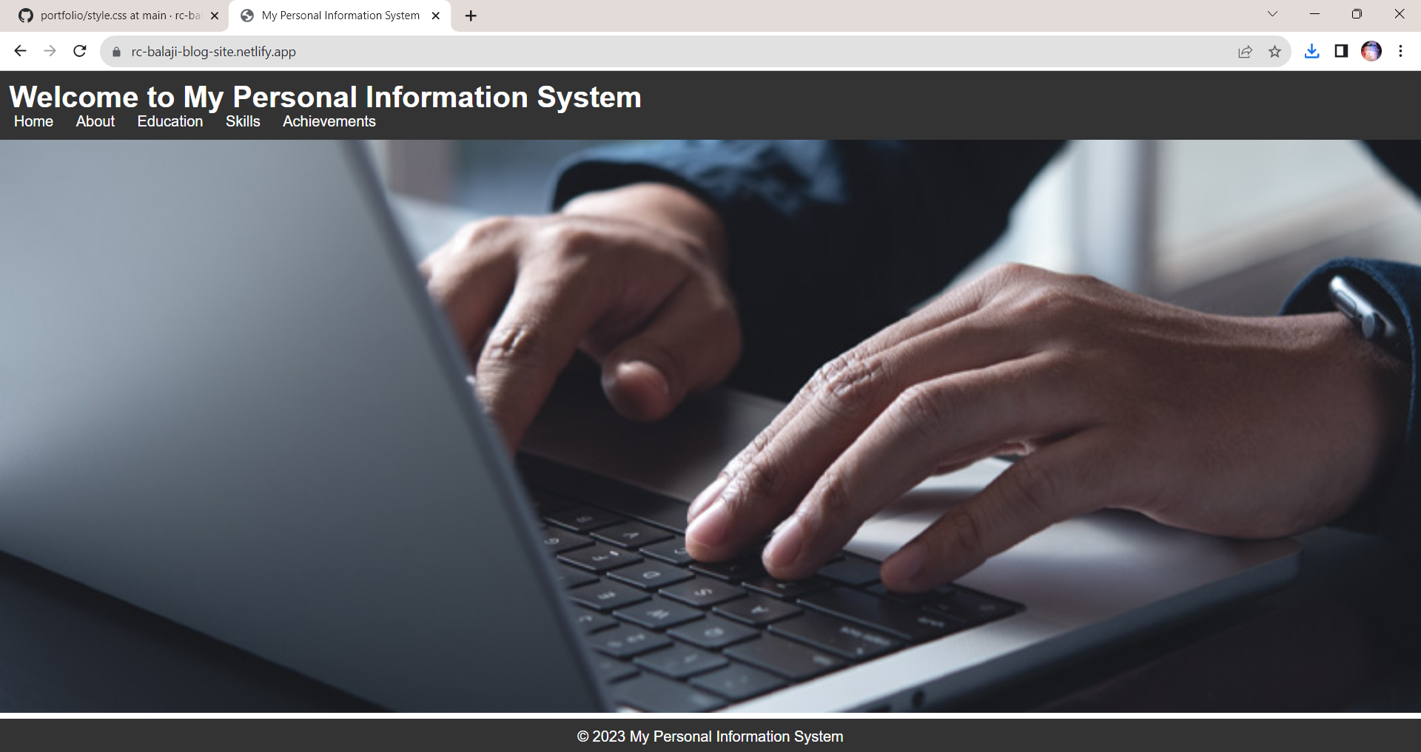

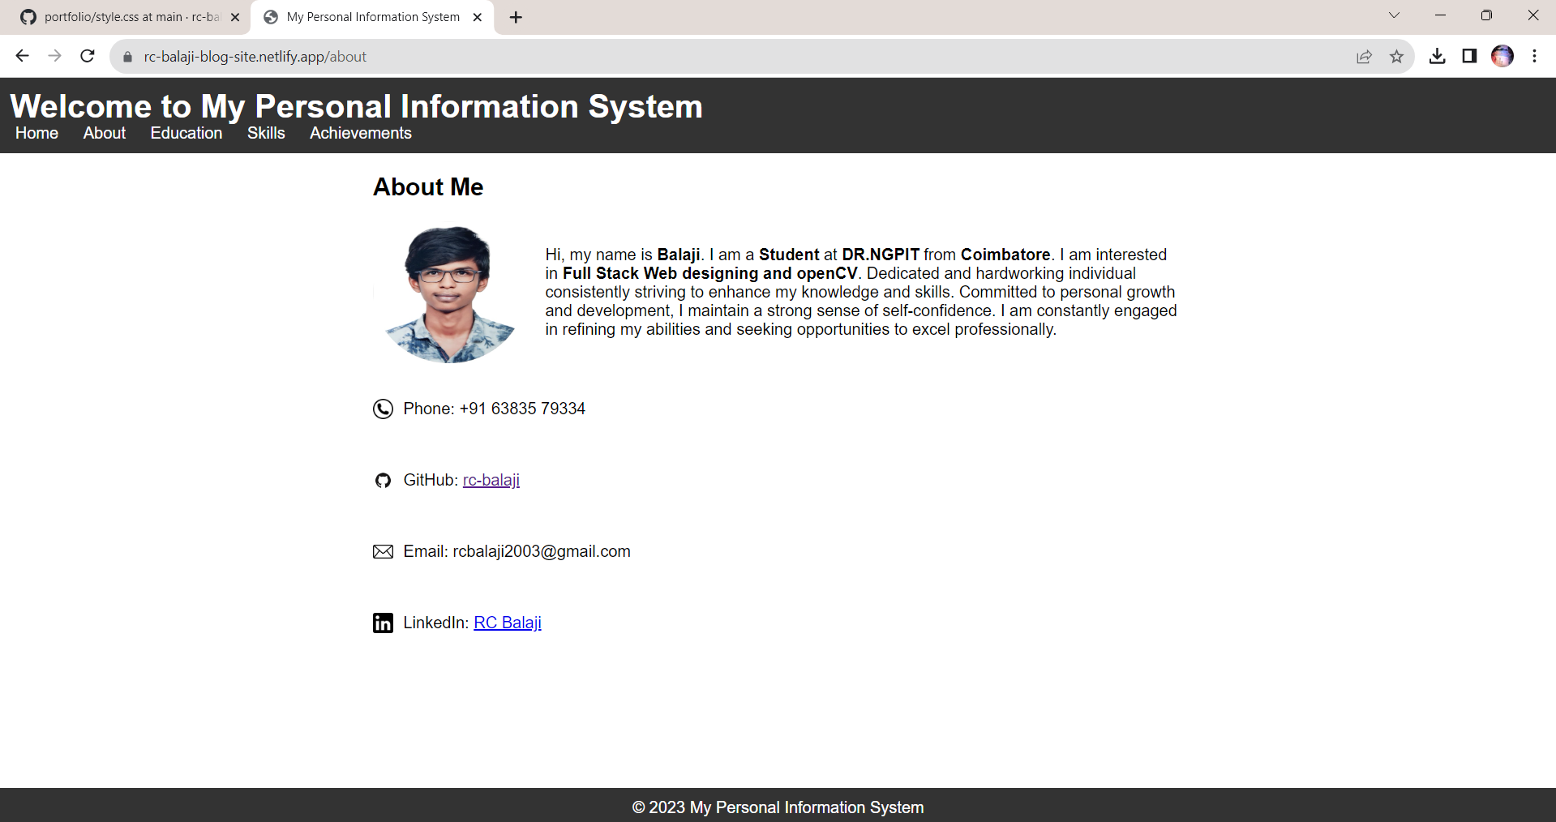

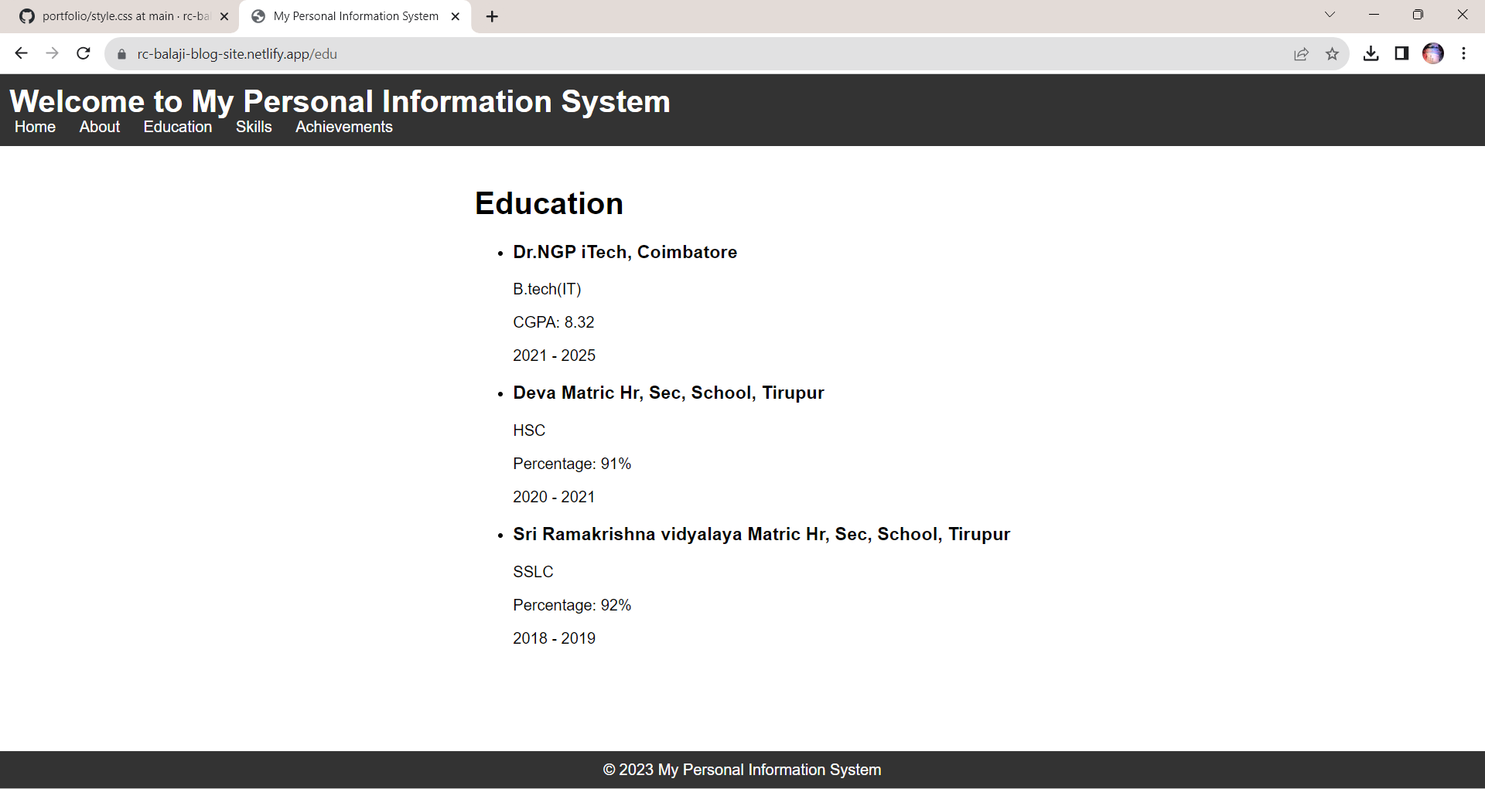

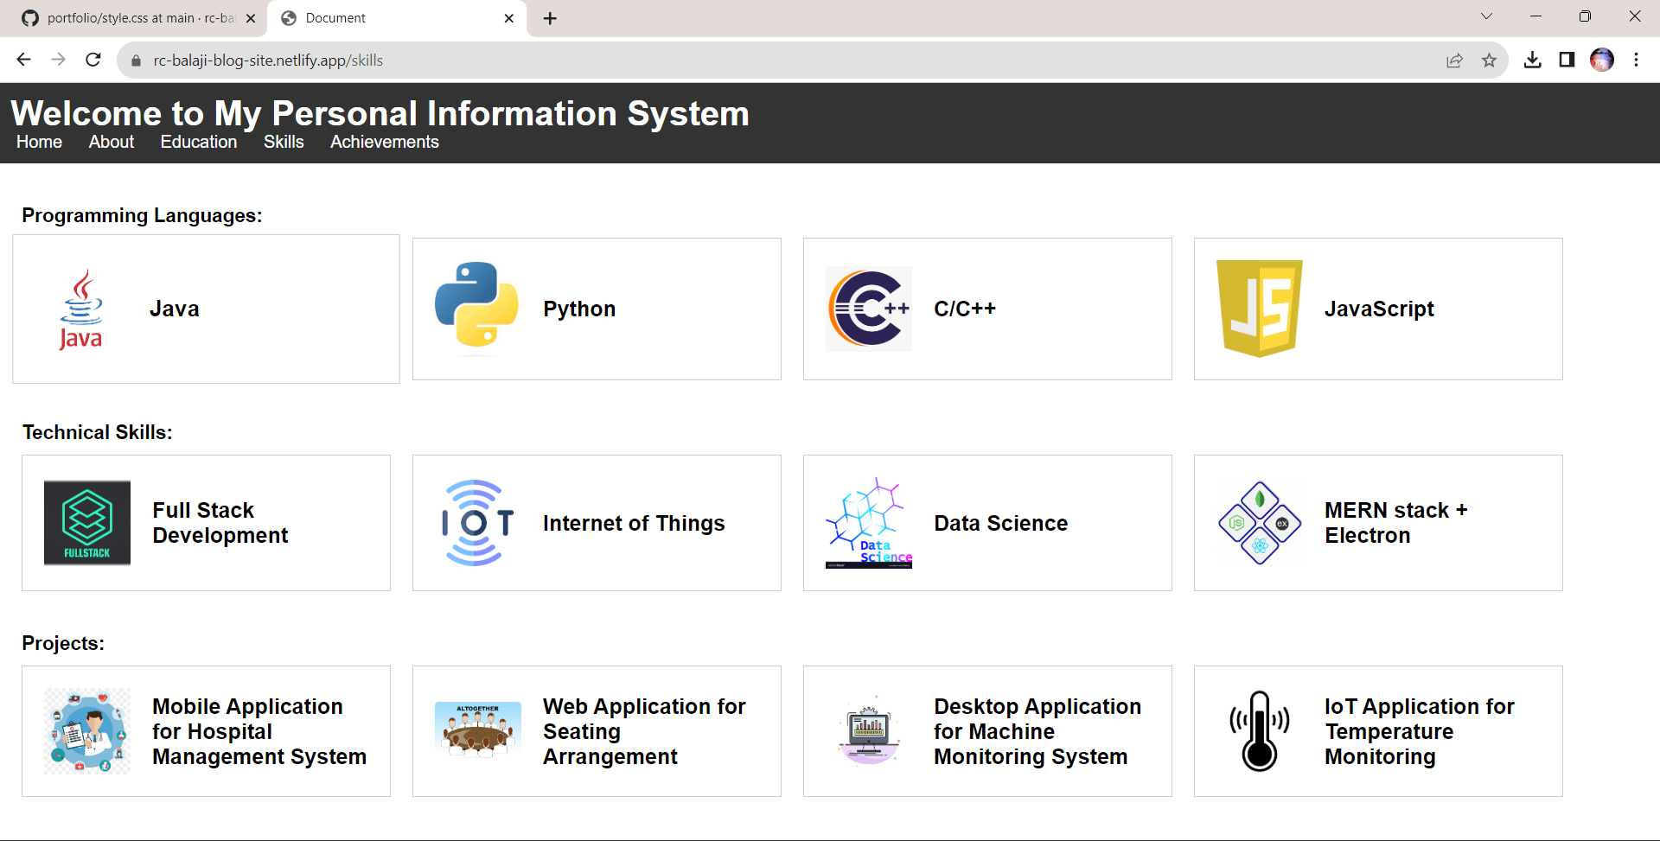



**Result:**

Thus the portfolio website has been developed successfully and the output has been verified.

|  |  |
| --- | --- |
| **Ex No:02** | **Create a web application to manage the TO-DO list of users, where users can login and manage their to-do items** |
| **Date:** |

**Aim:**

To Create a web application to manage the TO-DO list of users, where users can login and manage their to-do items.

**Algorithm:**

Step 1 : Start the program

Step 2 : Create a login page to enter into website

Step 3 : Create a page to enter task and due date with time

Step 4 : List out the entered task with due date and time

Step 5 : Provide the users with the option to mark the task as done and to delete the same for each tasks assigned

Step 6 : Using alert message, remaind the user with a beep alarm to do the tasks assigned when it is the due time

Step 7 : Stop the progarm

**Program:**

**Index.php**

<!DOCTYPE html>

<html lang="en">

<head>

<meta charset="UTF-8">

<meta http-equiv="X-UA-Compatible" content="IE=edge">

<meta name="viewport" content="width=device-width, initial-scale=1.0">

<title>To-Do List</title>

<link rel="stylesheet" href="style.css">

<style>

@import url('https://fonts.googleapis.com/css2?family=Poppins:wght@300;400;500;600;700;800;900&display=swap');

*

{

margin: 0;

padding: 0;

box-sizing: border-box;

font-family: 'Poppins', sans-serif;

}

body

{

display: flex;

justify-content: center;

align-items: center;

min-height: 100vh;

flex-direction: column;

background-image: url("bg.png");

background-repeat: no-repeat;

background-size: cover;

}

.body

{

position: relative;

width: 680px;

height: auto;

background: #1c1c1c;

border-radius: 8px;

overflow: hidden;

}

.completed-button{

text-decoration: none;

}

.top-btn,.completed-button,.complete-button{

padding: 5px 10px;

background-color: #ff5b57;

color: #fff;

border: none;

border-radius: 4px;

cursor: pointer;

}

.top-btn:hover,.completed-button:hover{

background-color:black;

}

.top-btn:hover{

background-color:black;

border: 1px solid white;

}

.top-buttons{

margin-bottom: 30px;

margin-left: 460px;

margin-top: 40px;

}

.create-todo input[type="submit"]{

border: none;

outline: none;

padding: 8px;

background-color: #9026d7;

cursor: pointer;

border-radius: 4px;

font-weight: 600;

width: 100px;

color: black;

margin-bottom: 30px;

}

.create-todo input[type="text"],

.create-todo input[type="datetime-local"] {

background-color: #45f3ff;

}

</style>

</head>

<body>

<div class="top-buttons">

<button class="top-btn" >

<a href="completed.php" class="completed-button">Completed</a></button>

<button class="top-btn"> <a href="login.php" class="completed-button">Sign Out</a></button>

</div>

<div class="body" >

<main class="app">

<section class="greeting">

<h2 class="title" style="color:#45f3ff" >

What's up, Balaji

</h2>

</section>

<section class="create-todo">

<h3 style="color:#45f3ff" >CREATE A TODO</h3>

<form action="index.php" method="post" id="new-todo-form">

<div class="task-input">

<input type="text" name="content" id="content" placeholder="e.g. finish homework" onchange="setName(this.value)" required>

</div>

<div class="datetime-input">

<input type="datetime-local" name="createdAt" id="createdAt" onchange="setDate(this.value)" required>

</div>

<div class="add-button">

<input type="submit" value="Add todo">

</div>

</form>

</section style="color:#45f3ff" >

<!-- TODO List -->

<h3 style="color:#45f3ff" >TODO LIST</h3>

<table style="background-color:#45f3ff" class="list" id="todo-list">

<tr class="list-header">

<th>S.no</th>

<th>Task</th>

<th>Deadline</th>

<th>Status</th>

</tr>

<?php echo DisplayTodos(); ?>

</table>

</section>

<!-- End of Todo List -->

</main>

</div>

<script>

function completeItem(index) {

window.location.href = 'index.php?complete=' + index;

}

function clearAll() {

if (confirm('Are you sure you want to clear all completed tasks?')) {

window.location.href = 'index.php?clearall';

}

}

function setDate(value) {

var selectedTime = value.slice(11, 16);

}

function setName(value) {

var inputName = value;

} </script>

<?php

function readTodos() {

$todos = json_decode(file_get_contents('todos.json'), true) ?: [];

return $todos;

}

function writeTodos($todos) {

file_put_contents('todos.json', json_encode($todos, JSON_PRETTY_PRINT));

}

function readCompleted() {

$completed = json_decode(file_get_contents('completed.json'), true) ?: [];

return $completed;

}

function writeCompleted($completed) {

file_put_contents('completed.json', json_encode($completed, JSON_PRETTY_PRINT | JSON_UNESCAPED_UNICODE));

}

function DisplayTodos()

{

$todos = readTodos();

$todoList = '';

$counter = 1;

if ($_SERVER['REQUEST_METHOD'] === 'POST') {

if (isset($_POST['content']) && isset($_POST['createdAt'])) {

$content = $_POST['content'];

$createdAt = $_POST['createdAt'];

if (!empty($content) && !empty($createdAt)) {

$todo = [

'content' => $content,

'done' => false,

'createdAt' => $createdAt

];

$todos[] = $todo;

writeTodos($todos);

}

header("Location: index.php");

exit();

}

}

if (isset($_GET['complete'])) {

$index = $_GET['complete'];

if (isset($todos[$index])) {

$completed = readCompleted();

$completedTodo = $todos[$index];

date_default_timezone_set('Asia/Kolkata');

$completedTodo['completedAt'] = date('Y-m-d H:i:s');

$completed[] = $completedTodo;

unset($todos[$index]);

writeCompleted($completed);

writeTodos($todos);

header("Location: index.php");

exit();

}

}

if (empty($todos)) {

$todoList .= '<tr><td colspan="4" class="no-task">No Task Available</td></tr>';

} else {

foreach ($todos as $index => $todo) {

$todoList .= '<tr class="todo-item">';

$todoList .= '<td class="sno">' . $counter . '.</td>';

$todoList .= '<td class="task">' . htmlspecialchars($todo['content']) . '</td>';

$todoList .= '<td class="deadline">';

$todoList .= 'Date: ' . date('d.m.Y', strtotime($todo['createdAt'])) . '<br>';

$todoList .= 'Time: ' . date('H:i', strtotime($todo['createdAt']));

$todoList .= '</td>';

$todoList .= '<td class="status">';

$todoList .= '<button class="complete-button" onclick="completeItem(' . $index . ')">Complete</button>';

$todoList .= '</td>';

$todoList .= '</tr>';

$counter++;

}

}

return $todoList;

}

?>

<script>

const alertsShown = {};

setInterval(checkDeadlines, 1000);

function checkDeadlines() {

const now = new Date();

const todos = <?php echo json_encode(readTodos()); ?>;

todos.forEach(todo => {

const deadline = new Date(todo.createdAt);

if (deadline < now && !alertsShown[todo.content]) {

alertsShown[todo.content] = true;

alert(`Time to ${todo.content}`);

}

});

}

</script>

</body>

</html>

**Login.php**

<!DOCTYPE html>

<html lang="en">

<head>

<meta charset="UTF-8">

<meta http-equiv="X-UA-Compatible" content="IE=edge">

<meta name="viewport" content="width=device-width, initial-scale=1.0">

<title>Login</title>

<style>

@import url('https://fonts.googleapis.com/css2?family=Poppins:wght@300;400;500;600;700;800;900&display=swap');

*

{

margin: 0;

padding: 0;

box-sizing: border-box;

font-family: 'Poppins', sans-serif;

}

body

{

display: flex;

justify-content: center;

align-items: center;

min-height: 100vh;

flex-direction: column;

background-image: url("bg.png");

background-repeat: no-repeat;

background-size: cover;

}

.box

{

position: relative;

width: 380px;

height: 420px;

background: #1c1c1c;

border-radius: 8px;

overflow: hidden;

}

@keyframes animate

{

0%

{

transform: rotate(0deg);

}

100%

{

transform: rotate(360deg);

}

}

form

{

position: absolute;

inset: 2px;

background: #28292d;

padding: 50px 40px;

border-radius: 8px;

z-index: 2;

display: flex;

flex-direction: column;

}

h2

{

color: #45f3ff;

font-weight: 500;

text-align: center;

letter-spacing: 0.1em;

}

.inputBox

{

position: relative;

width: 300px;

margin-top: 35px;

}

.inputBox input

{

position: relative;

width: 100%;

padding: 20px 10px 10px;

background: transparent;

outline: none;

box-shadow: none;

border: none;

color: #23242a;

font-size: 1em;

letter-spacing: 0.05em;

transition: 0.5s;

z-index: 10;

}

.inputBox span

{

position: absolute;

left: 0;

padding: 20px 0px 10px;

pointer-events: none;

font-size: 1em;

color: #8f8f8f;

letter-spacing: 0.05em;

transition: 0.5s;

}

.inputBox input:valid ~ span,

.inputBox input:focus ~ span

{

color: #45f3ff;

transform: translateX(0px) translateY(-34px);

font-size: 0.75em;

}

.inputBox i

{

position: absolute;

left: 0;

bottom: 0;

width: 100%;

height: 2px;

background: #45f3ff;

border-radius: 4px;

overflow: hidden;

transition: 0.5s;

pointer-events: none;

z-index: 9;

}

.inputBox input:valid ~ i,

.inputBox input:focus ~ i

{

height: 44px;

}

.links

{

display: flex;

justify-content: space-between;

}

.links a

{

margin: 10px 0;

font-size: 0.75em;

color: #8f8f8f;

text-decoration: beige;

}

.links a:hover,

.links a:nth-child(2)

{

color: #45f3ff;

}

input[type="submit"]

{

border: none;

outline: none;

padding: 11px 25px;

background: #45f3ff;

cursor: pointer;

border-radius: 4px;

font-weight: 600;

width: 100px;

margin-top: 10px;

}

input[type="submit"]:active

{

opacity: 0.8;

}

h1{

color: #45f3ff;

margin-bottom: 30px;

}

</style>

</head>

<body>

<h1>Welcome you to To-Do List</h1>

<div class="box">

<form autocomplete="off" name="myform" action="index.php" method="post" id="login-form" onsubmit="return check()">

<h2>Log in</h2>

<div class="inputBox">

<input type="text" name="username" id="username" required>

<span>Userame</span>

<i></i>

</div>

<div class="inputBox">

<input type="password" name="password" id="password" required>

<span>Password</span>

<i></i>

</div>

<div class="links">

<a href="#">Forgot Password ?</a>

<a href="#">Signup</a>

</div>

<input type="submit" value="Login">

</form>

</div>

<script>

function check() {

let user = document.forms["myform"]["username"].value;

let pass = Number(document.forms["myform"]["password"].value);

const username = ["sam", "ram", "raj"];

const password = [123, 234, 456];

t = 0;

for (let i = 0; i < 3; i++) {

if (user === username[i] && pass === password[i]) {

t = 1;

} else if (user === username[i] && pass !== password[i]) {

t = 2;

}

}

if (t === 1) {

setTimeout(function () {

document.getElementById("login-form").submit();

}, 500);

return false;

} else if (t === 2) {

alert("Incorrect Pass");

return false;

} else {

alert("Not found");

return false;

}

}

</script>

</body>

</html>

**completed.php**

<!DOCTYPE html>

<html lang="en">

<head>

<meta charset="UTF-8">

<meta http-equiv="X-UA-Compatible" content="IE=edge">

<meta name="viewport" content="width=device-width, initial-scale=1.0">

<title>Login</title>

<style>

@import url('https://fonts.googleapis.com/css2?family=Poppins:wght@300;400;500;600;700;800;900&display=swap');

*

{

margin: 0;

padding: 0;

box-sizing: border-box;

font-family: 'Poppins', sans-serif;

}

body

{

display: flex;

justify-content: center;

align-items: center;

min-height: 100vh;

flex-direction: column;

background-image: url("bg.png");

background-repeat: no-repeat;

background-size: cover;

}

.box

{

position: relative;

width: 380px;

height: 420px;

background: #1c1c1c;

border-radius: 8px;

overflow: hidden;

}

@keyframes animate

{

0%

{

transform: rotate(0deg);

}

100%

{

transform: rotate(360deg);

}

}

form

{

position: absolute;

inset: 2px;

background: #28292d;

padding: 50px 40px;

border-radius: 8px;

z-index: 2;

display: flex;

flex-direction: column;

}

h2

{

color: #45f3ff;

font-weight: 500;

text-align: center;

letter-spacing: 0.1em;

}

.inputBox

{

position: relative;

width: 300px;

margin-top: 35px;

}

.inputBox input

{

position: relative;

width: 100%;

padding: 20px 10px 10px;

background: transparent;

outline: none;

box-shadow: none;

border: none;

color: #23242a;

font-size: 1em;

letter-spacing: 0.05em;

transition: 0.5s;

z-index: 10;

}

.inputBox span

{

position: absolute;

left: 0;

padding: 20px 0px 10px;

pointer-events: none;

font-size: 1em;

color: #8f8f8f;

letter-spacing: 0.05em;

transition: 0.5s;

}

.inputBox input:valid ~ span,

.inputBox input:focus ~ span

{

color: #45f3ff;

transform: translateX(0px) translateY(-34px);

font-size: 0.75em;

}

.inputBox i

{

position: absolute;

left: 0;

bottom: 0;

width: 100%;

height: 2px;

background: #45f3ff;

border-radius: 4px;

overflow: hidden;

transition: 0.5s;

pointer-events: none;

z-index: 9;

}

.inputBox input:valid ~ i,

.inputBox input:focus ~ i

{

height: 44px;

}

.links

{

display: flex;

justify-content: space-between;

}

.links a

{

margin: 10px 0;

font-size: 0.75em;

color: #8f8f8f;

text-decoration: beige;

}

.links a:hover,

.links a:nth-child(2)

{

color: #45f3ff;

}

input[type="submit"]

{

border: none;

outline: none;

padding: 11px 25px;

background: #45f3ff;

cursor: pointer;

border-radius: 4px;

font-weight: 600;

width: 100px;

margin-top: 10px;

}

input[type="submit"]:active

{

opacity: 0.8;

}

h1{

color: #45f3ff;

margin-bottom: 30px;

}

</style>

</head>

<body>

<h1>Welcome you to To-Do List</h1>

<div class="box">

<form autocomplete="off" name="myform" action="index.php" method="post" id="login-form" onsubmit="return check()">

<h2>Log in</h2>

<div class="inputBox">

<input type="text" name="username" id="username" required>

<span>Userame</span>

<i></i>

</div>

<div class="inputBox">

<input type="password" name="password" id="password" required>

<span>Password</span>

<i></i>

</div>

<div class="links">

<a href="#">Forgot Password ?</a>

<a href="#">Signup</a>

</div>

<input type="submit" value="Login">

</form>

</div>

<script>

function check() {

let user = document.forms["myform"]["username"].value;

let pass = Number(document.forms["myform"]["password"].value);

const username = ["sam", "ram", "raj"];

const password = [123, 234, 456];

t = 0;

for (let i = 0; i < 3; i++) {

if (user === username[i] && pass === password[i]) {

t = 1;

} else if (user === username[i] && pass !== password[i]) {

t = 2;

}

}

if (t === 1) {

setTimeout(function () {

document.getElementById("login-form").submit();

}, 500);

return false;

} else if (t === 2) {

alert("Incorrect Pass");

return false;

} else {

alert("Not found");

return false;

}

}

</script>

</body>

</html>

**Output:**

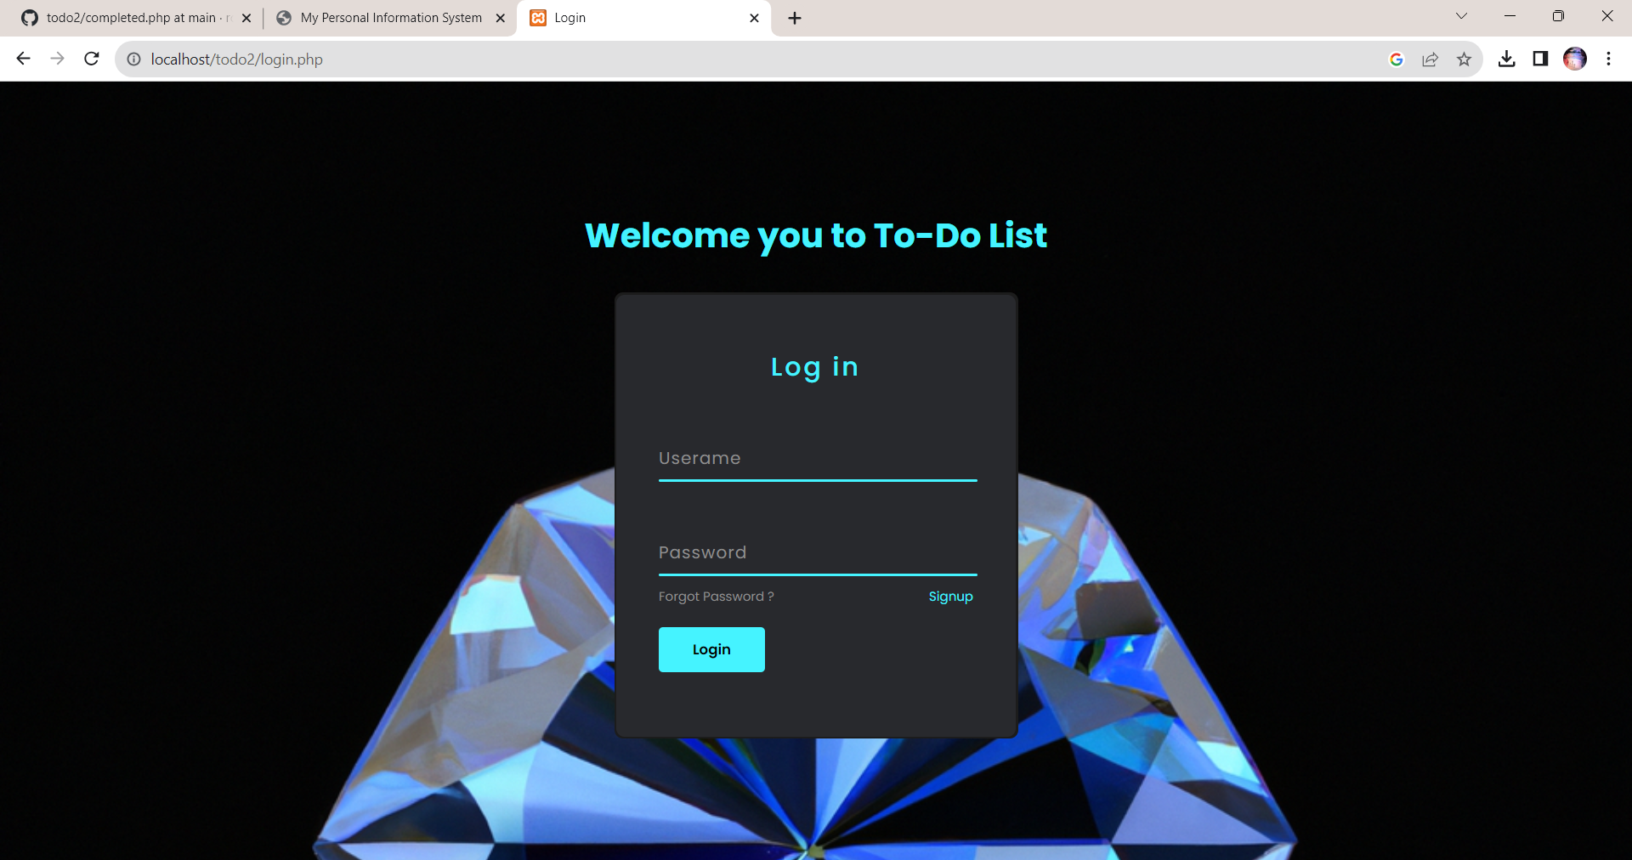

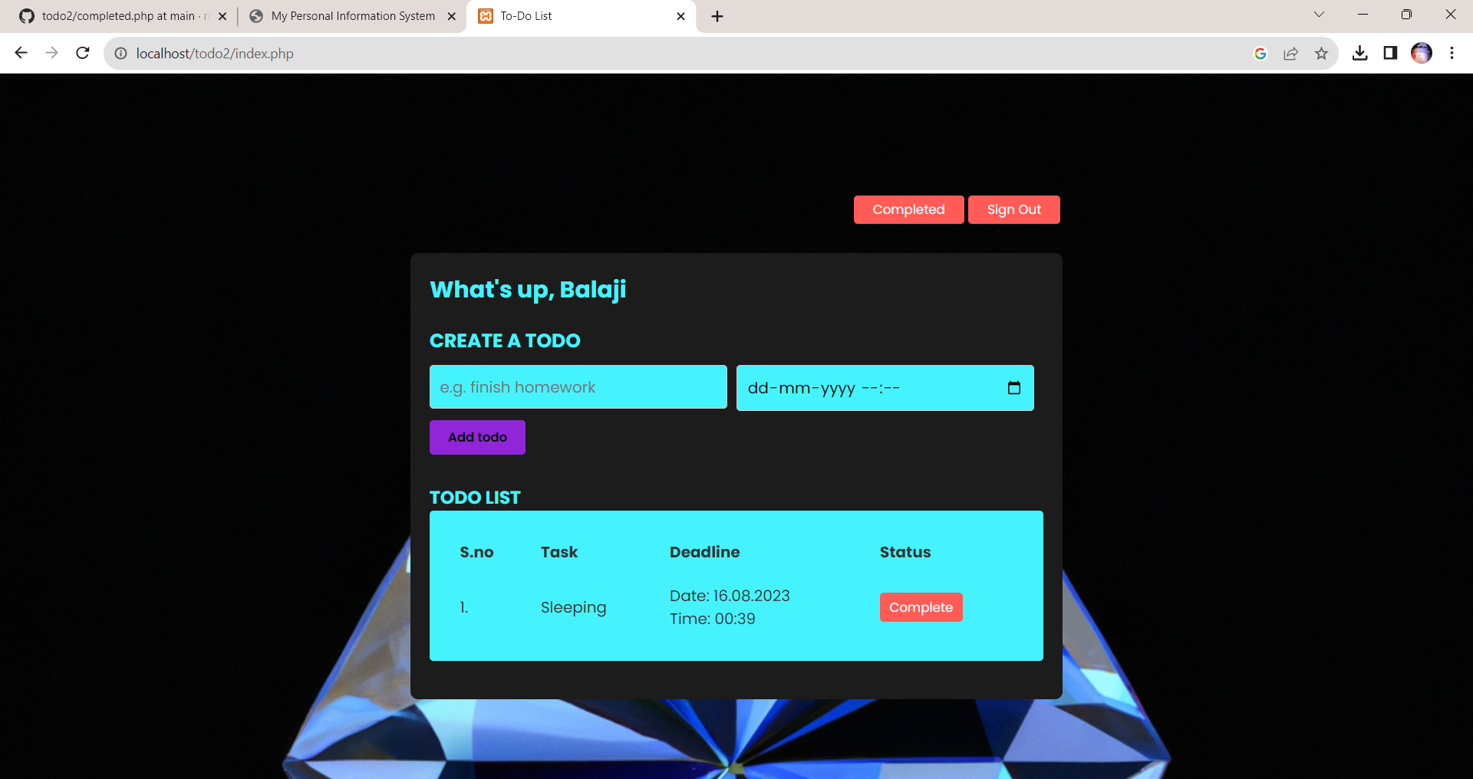

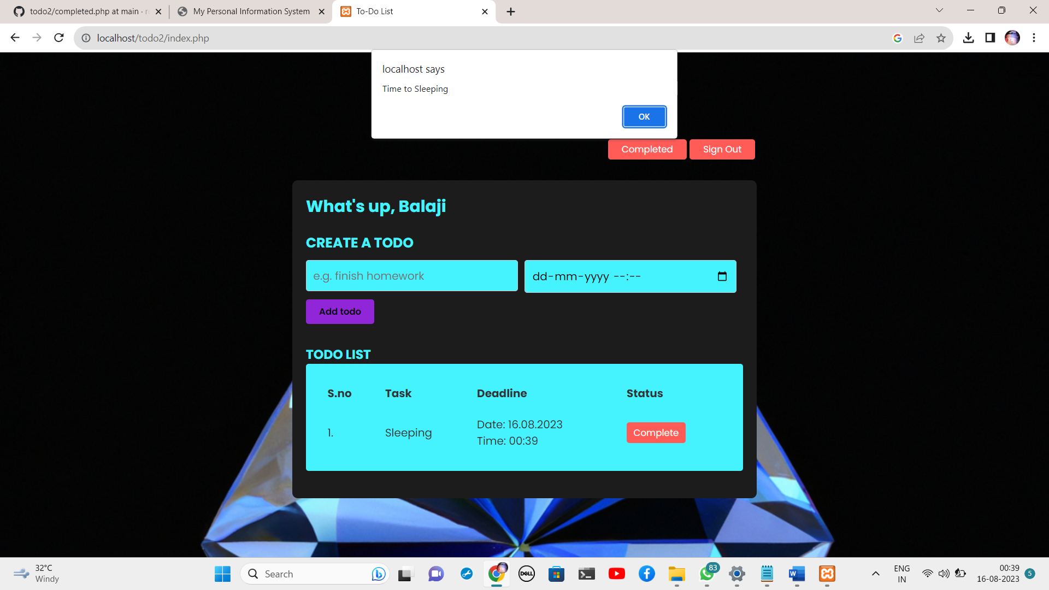

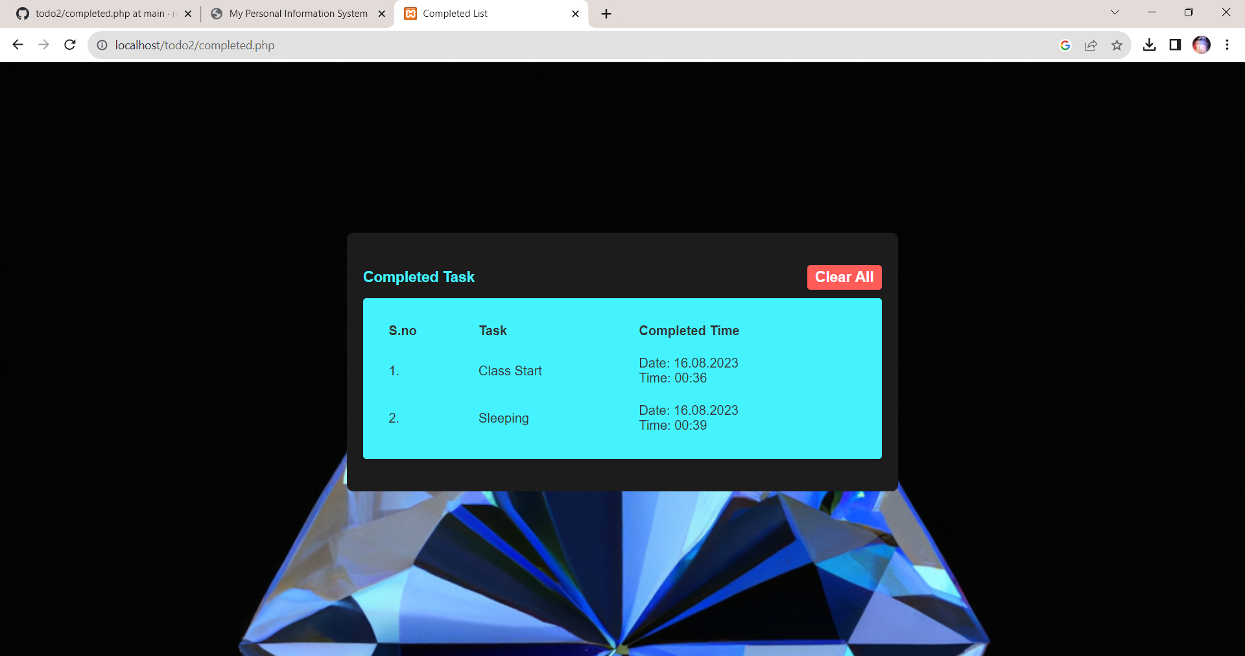

**Result:**

Thus the creation of web application to manage the todo list has been done successfully and the output

is verified.

|  |  |
| --- | --- |
| **Ex No:05** | **Develop a classifieds web application to** **buy and sell used products** |
| **Date:** |

**Aim:**

To Create a web application to buy and sell used products.

**Algorithm:**

Step 1 : Start the program

Step 2 : Create a login page to enter into website

Step 3 : Create page for buy a products ,sell a products

Step 4 : Create a page for Display a Products

Step 5 : Provide a action to Contact of the Owners

Step 6 : Create a page to place the order

Step 7 :Stop the progarm

**Program:**

Index.php

<?php

require_once "dbconnection.php";

require_once "session.php";

if ($_SERVER["REQUEST_METHOD"] == "POST" && isset($_POST['submit'])) {

$email = $_POST['email'];

$password = $_POST['password'];

$qry = "SELECT * FROM `login` WHERE `email`='$email' AND `password`='$password'";

$run = mysqli_query($dbcon, $qry);

$row = mysqli_num_rows($run);

if ($row < 1) {

?>

<script>

// alert("Invalid ID/Password");

window.open('index.php', '_self');

</script>

<?php

} else {

$data = mysqli_fetch_assoc($run);

$id = $data['u_id'];

$email = $data['email'];

$_SESSION['uid'] = $id;

$_SESSION['emm'] = $email;

?>

<script>

setTimeout(() => {

// alert('welcome')

window.open('home/home.php', '_self');

}, 500);

</script>

<?php

}

}

?>

<!DOCTYPE html>

<html lang="en">

<head>

<meta charset="UTF-8">

<meta name="viewport" content="width=device-width, initial-scale=1.0">

<title>Login</title>

<link rel="stylesheet" href="https://stackpath.bootstrapcdn.com/bootstrap/4.4.1/css/bootstrap.min.css">

</head>

<body>

<h1>Welcome you to ToSell </h1>

<h5 style="margin-left:350px">--RC Balaji</h5>

<div class="box">

<?php echo $error; ?>

<form autocomplete="off" name="myform" id="login-form" action="" method="post">

<div class="inputBox">

<input type="text" name="email" id="username" required>

<span>Email</span>

<i></i>

</div>

<div class="inputBox">

<input type="password" name="password" id="password" required>

<span>Password</span>

<i></i>

</div>

<div class="links">

<a href="resetpswd.php">Forgot Password ?</a>

<a href="register.php">Signup</a>

</div>

<input type="submit" name="submit" class="btn btn-primary" value="SignIn" />

</form>

</div>

</body>

</html>

AddProducts.php

<?php

session_start();

if (!isset($_SESSION['uid'])) {

header('location: ../index.php');

exit();

}

include('header.php');

include('../dbconnection.php');

if (isset($_POST['submit'])) {

$user_id = $_SESSION['uid'];

$category = $_POST['category'];

$title = $_POST['title'];

$description = $_POST['description'];

$condition = $_POST['condition'];

$price = $_POST['price'];

$photo_name = $_FILES['photo']['name'];

$temp_name = $_FILES['photo']['tmp_name'];

$username_query = "SELECT name FROM users WHERE u_id = '$user_id'";

$username_result = mysqli_query($dbcon, $username_query);

$username_row = mysqli_fetch_assoc($username_result);

$username = $username_row['name'];

move_uploaded_file($temp_name, "../product_images/$photo_name");

if ($category === 'phone') {

$brand_name = $_POST['brand_name'];

$ram = $_POST['ram'];

$rom = $_POST['rom'];

$qry = "INSERT INTO products_phones (user_id, category, title, description, conditions, price, photo, brand_name, ram, rom, username)

VALUES ('$user_id', '$category', '$title', '$description', '$condition', '$price', '$photo_name', '$brand_name', '$ram', '$rom', '$username')";

} elseif ($category === 'bike' || $category === 'car') {

$mileage = $_POST['mileage'];

$kilometers_driven = $_POST['kilometers_driven'];

$qry = "INSERT INTO products_" . $category . "s (user_id, category, title, description, conditions, price, photo, mileage, kilometers_driven, username)

VALUES ('$user_id', '$category', '$title', '$description', '$condition', '$price', '$photo_name', '$mileage', '$kilometers_driven', '$username')";

} elseif ($category === 'electronics') {

$usage_time = $_POST['usage_time'];

$qry = "INSERT INTO products_electronic (user_id, category, title, description, conditions, price, photo, usage_time, username)

VALUES ('$user_id', '$category', '$title', '$description', '$condition', '$price', '$photo_name', '$usage_time', '$username')";

} else {

echo "<script>alert('Invalid category');</script>";

}

$result1 = mysqli_query($dbcon, $qry);

if ($result1) {

header('location: AddProducts.php'); // Redirect after successful submission

echo "<script>alert('Product added successfully');</script>";

exit();

} else {

echo "<script>alert('Error adding product');</script>";

}

}

?>

<!DOCTYPE html>

<html lang="en">

<head>

<meta charset="UTF-8">

<meta name="viewport" content="width=device-width, initial-scale=1.0">

<title>Add New Product</title>

</head>

<body style="background-color:white">

<div class="container">

<div class="form-header">

<h2>Add New Product</h2>

</div>

<div class="form-container">

<form action="" method="POST" enctype="multipart/form-data">

<div class="form-group">

<label for="category">Category</label>

<select name="category" id="category">

<option value="phone">Phone</option>

<option value="bike">Bike</option>

<option value="car">Car</option>

<option value="electronics">Electronics</option>

</select>

</div>

<div class="form-group">

<label for="title">Title</label>

<input type="text" name="title">

</div>

<div class="form-group">

<label for="description">Description</label>

<textarea name="description" placeholder="Enter product description" rows="4" cols="50"></textarea>

</div>

<div class="form-group">

<label for="condition">Condition</label>

<select name="condition">

<option value="new">New</option>

<option value="used">Used</option>

</select>

</div>

<div class="form-group">

<label for="price">Price ($)</label>

<input type="number" step="0.01" name="price">

</div>

<div class="form-group">

<label for="photo">Upload Photo</label>

<label class="custom-file-upload">

Choose File

<input type="file" name="photo" accept="image/*">

</label>

</div>

<div class="image-preview">

<img id="imagePreview" src="#" alt="Preview" style="display: none;">

</div>

<!-- Additional fields for each category -->

<div class="form-group" id="phone-fields"> <!-- Displayed by default -->

<label for="brand_name">Brand Name</label>

<input type="text" name="brand_name">

<label for="ram">RAM (GB)</label>

<input type="number" name="ram">

<label for="rom">ROM (GB)</label>

<input type="number" name="rom">

</div>

<div class="form-group" id="bike-fields" style="display: none;">

<label for="mileage">Mileage (km/l)</label>

<input type="number" name="mileage">

<label for="kilometers_driven">Kilometers Driven</label>

<input type="number" name="kilometers_driven">

</div>

<div class="form-group" id="car-fields" style="display: none;">

<label for="mileage">Mileage (km/l)</label>

<input type="number" name="mileage">

<label for="kilometers_driven">Kilometers Driven</label>

<input type="number" name="kilometers_driven">

</div>

<div class="form-group" id="electronics-fields" style="display: none;">

<label for="usage_time">Usage Time</label>

<input type="text" name="usage_time">

</div>

<div class="form-group">

<input type="submit" name="submit" value="Add Product">

</div>

</form>

</div>

</div>

<script>

const categorySelect = document.getElementById('category');

const phoneFields = document.getElementById('phone-fields');

const bikeFields = document.getElementById('bike-fields');

const carFields = document.getElementById('car-fields');

const electronicsFields = document.getElementById('electronics-fields');

// Set the initial display for the phone category

phoneFields.style.display = 'block';

categorySelect.addEventListener('change', function () {

const selectedCategory = this.value;

phoneFields.style.display = selectedCategory === 'phone' ? 'block' : 'none';

bikeFields.style.display = selectedCategory === 'bike' ? 'block' : 'none';

carFields.style.display = selectedCategory === 'car' ? 'block' : 'none';

electronicsFields.style.display = selectedCategory === 'electronics' ? 'block' : 'none';

});

const fileInput = document.querySelector('input[type="file"]');

fileInput.addEventListener('change', function () {

const file = this.files[0];

if (file) {

const reader = new FileReader();

reader.onload = function (e) {

imagePreview.style.display = 'block';

imagePreview.src = e.target.result;

}

reader.readAsDataURL(file);

}

});

</script>

</body>

</html>

BuyProducts.php

<?php

session_start();

include('header.php');

include('../dbconnection.php');

if (isset($_GET['product_id'])) {

$product_id = $_GET['product_id'];

$category = $_GET['category']; // Add this line to get the category from the URL

// Determine the table name based on the category

$table = "products_" . ($category === 'electronics' ? "electronic" : $category . 's');

// Query the specific category table for the product

$query = "SELECT * FROM $table WHERE product_id = $product_id";

$result = mysqli_query($dbcon, $query);

if ($result && mysqli_num_rows($result) > 0) {

$row = mysqli_fetch_assoc($result);

// Display product details

echo "<div class='container'>";

echo "<h2>Product Details</h2>";

echo "<div class='product-details'>";

echo "<img src='../product_images/" . $row['photo'] . "' alt='Product Image' class='product-image'>";

echo "<div class='product-info'>";

echo "<h4>" . $row['title'] . "</h4>";

echo "<p><strong>Category:</strong> " . $category . "</p>";

echo "<p><strong>Description:</strong> " . $row['description'] . "</p>";

echo "<p><strong>Condition:</strong> " . $row['conditions'] . "</p>";

echo "<p><strong>Price:</strong> $" . $row['price'] . "</p>";

// Display user details

$user_id = $row['user_id'];

$user_query = "SELECT * FROM users WHERE u_id = $user_id";

$user_result = mysqli_query($dbcon, $user_query);

if ($user_result && mysqli_num_rows($user_result) > 0) {

$user_row = mysqli_fetch_assoc($user_result);

echo "<h2>Seller Details</h2>";

echo "<p><strong>Name:</strong> " . $user_row['name'] . "</p>";

echo "<p><strong>Email:</strong> " . $user_row['email'] . "</p>";

echo "<p><strong>Contact:</strong> " . $user_row['pnumber'] . "</p>";

}

// Add a "Place Order" button

echo '<button class="place-order" onclick="alert(\'Order Placed\')">Place Order</button>';

echo "</div>"; // Close the product-info div

echo "</div>"; // Close the product-details div

echo "</div>"; // Close the container div

} else {

echo "<p>Product not found.</p>";

}

} else {

echo "<p>Invalid product ID.</p>";

}

?>

MyProducts.php

<?php

session_start();

include('header.php');

include('../dbconnection.php');

if (isset($_SESSION['uid'])) {

$user_id = $_SESSION['uid'];

// Initialize an array to store the product categories

$productCategories = ['phones', 'bikes', 'cars', 'electronic'];

echo "<div class='container'>";

echo "<h2>My Products</h2>";

// Loop through each product category and fetch products associated with the user

foreach ($productCategories as $category) {

$table = "products_" . $category;

$query = "SELECT * FROM $table WHERE user_id = $user_id";

$result = mysqli_query($dbcon, $query);

if (mysqli_num_rows($result) > 0) {

echo "<h3>$category</h3>";

echo "<div class='category'>";

// Display products if there are any associated with your user ID

while ($row = mysqli_fetch_assoc($result)) {

echo "<div class='product'>";

echo "<img src='../product_images/" . $row['photo'] . "' alt='Product Image'>";

echo "<h4>" . $row['title'] . "</h4>";

echo "<p><strong>Category:</strong> " . $category . "</p>";

echo "<p><strong>Description:</strong> " . $row['description'] . "</p>";

echo "<p><strong>Condition:</strong> " . $row['conditions'] . "</p>";

echo "<p><strong>Price:</strong> $" . $row['price'] . "</p>";

echo "</div>";

}

echo "</div>"; // Close the category flex container

}

}

echo "</div>";

} else {

echo "<p>Please log in to view your products.</p>";

}

?>

**Output:-**

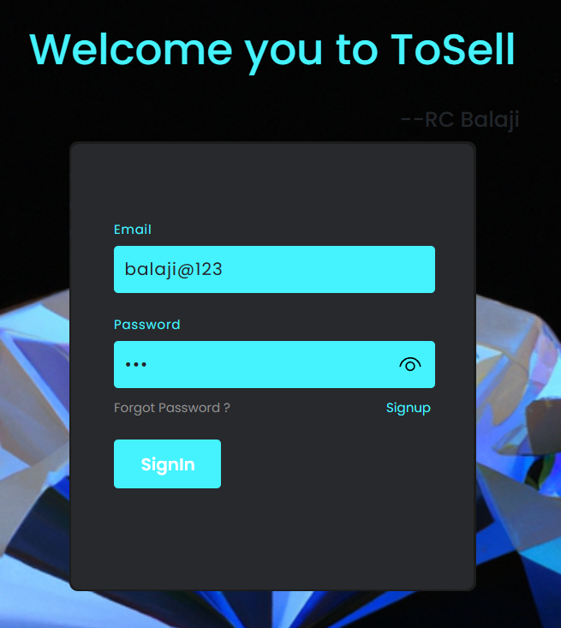

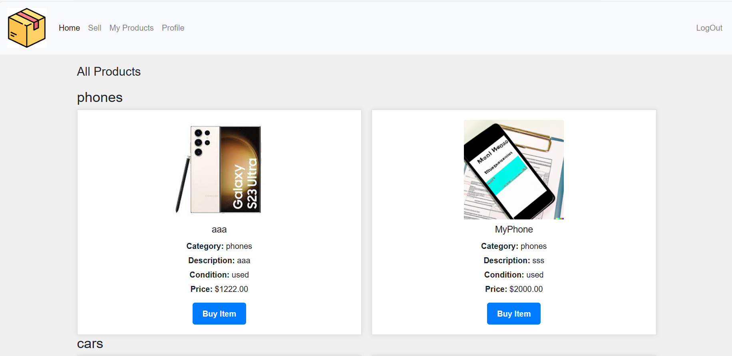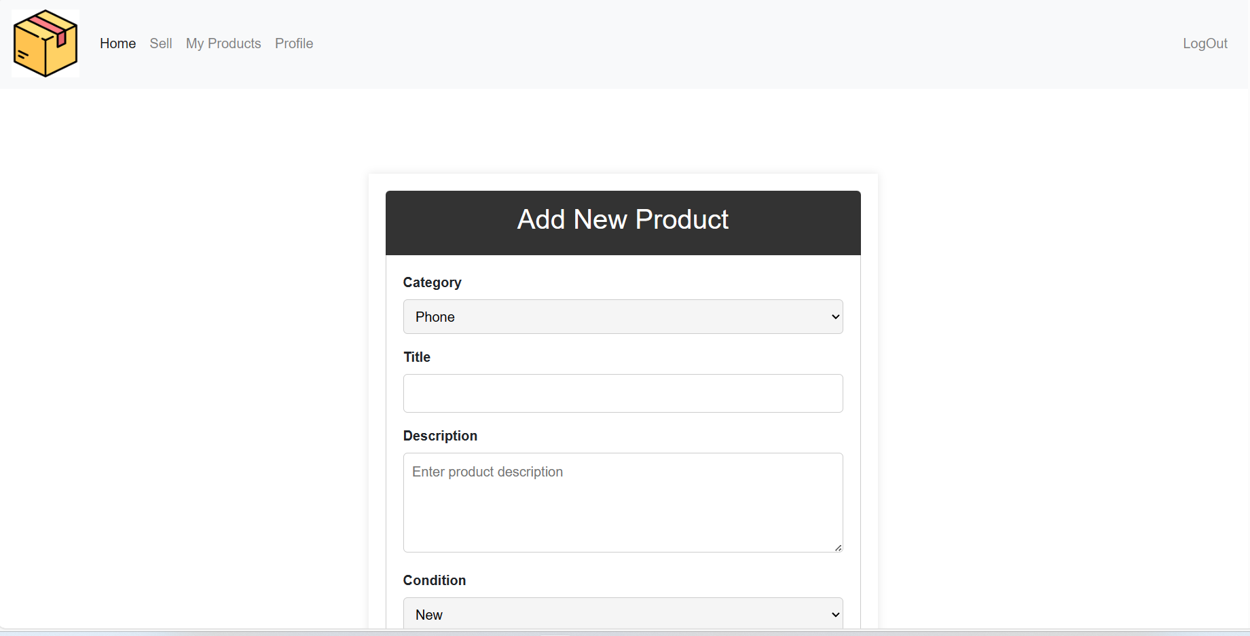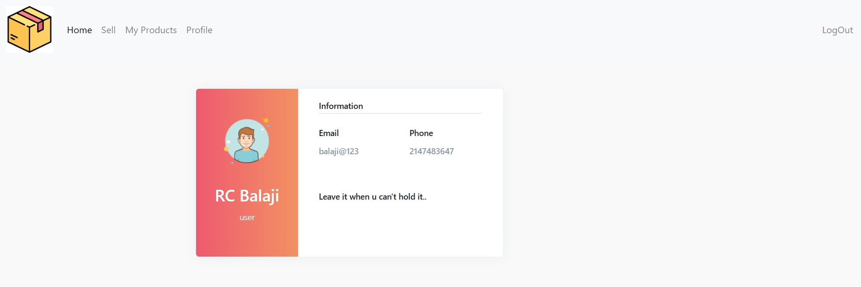

**Result:**

Thus the creation of web application to buy and sell used products has been done successfully and the output is verified.

|  |  |
| --- | --- |
| **Ex No:06** | **Develop a leave management system for an organization where users can apply different types of leaves such as casual leave and medical leave. They also can view the available**  **number of days.** |
| **Date:** |

**Aim:**

To Create a web application to develop a leave management system for an organization where users can apply different types of leaves such as casual leave and medical leave. They also can view the available

number of days.

**Algorithm:**

Step 1 : Start the program

Step 2 : Create a login page to enter into website

Step 3 : Create page for home to see the recend leaves

Step 4 : Create a page for apply the leaves

Step 5 : Create a page for Track the Leaves

Step 6 : Connected to the Firebase

Step 7 :Stop the progarm

**Program:**

App.jsx

import React from "react";

import { Index } from ".";

import { BrowserRouter, Routes, Route } from "react-router-dom";

import { Home } from "./Components/Home";

import { About } from "./Components/About";

import { Profile } from "./Components/Profile";

import { Contact } from "./Components/Contact";

import { SignUp } from "./Components/SignUp";

import { NotFound } from "./Components/NotFound";

import { Track } from "./Components/Track";

import { ApplyForLeave } from "./Components/ApplyForLeave";

const App = () => {

return (

<BrowserRouter>

<Routes>

<Route path="/" element={<Index />} />

<Route path="/home" element={<Home />} />

<Route path="/about" element={<About />} />

<Route path="/contact" element={<Contact />} />

<Route path="/signup" element={<SignUp />} />

<Route path="/profile" element={<Profile />} />

<Route path="/track" element={<Track />} />

<Route path="/apply" element={<ApplyForLeave />} />

<Route path="*" element={<NotFound />} />

</Routes>

</BrowserRouter>

);

};

export default App;

Home.jsx

import React, { useEffect, useState } from "react";

import { Navbar } from "./Navbar";

import { app } from "../firebase/firebase";

import {

getFirestore,

collection,

query,

orderBy,

limit,

onSnapshot,

getDoc,

doc,

} from "firebase/firestore";

import "./Home.css"; // Import the CSS file

import { auth } from "../firebase/firestore";

import { onAuthStateChanged } from "firebase/auth";

export const Home = () => {

const db = getFirestore(app);

const leavesCollection = collection(db, "leaves");

const user = auth.currentUser;

const [currentUser, setCurrentUser] = useState(null); // State to store the current user

const [leaveApplications, setLeaveApplications] = useState([]);

const [remainingDays, setRemainingDays] = useState(10); // You can initialize this with the actual number of days

// Function to convert Firestore Timestamp to formatted date and time string

const formatFirestoreTimestamp = (timestamp) => {

if (!timestamp) {

return ""; // Return an empty string or another appropriate value when timestamp is null

}

const date = timestamp.toDate();

const options = {

year: "numeric",

month: "long",

day: "numeric",

hour: "numeric",

minute: "numeric",

second: "numeric",

timeZoneName: "short",

};

return date.toLocaleDateString("en-US", options);

};

useEffect(() => {

// Listen for changes in authentication state

const unsubscribe = onAuthStateChanged(auth, (user) => {

if (user) {

setCurrentUser(user);

} else {

setCurrentUser(null);

}

});

return () => {

// Unsubscribe from the listener when the component unmounts

unsubscribe();

};

}, [auth]);

useEffect(() => {

if (!user) return;

const fetchData = async () => {

try {

// Modify the query to retrieve data for the currently authenticated user

const leavesQuery = query(

leavesCollection,

orderBy("timestamp", "desc"),

limit(10)

);

const unsubscribe = onSnapshot(leavesQuery, (querySnapshot) => {

const applications = [];

querySnapshot.forEach((doc) => {

const data = doc.data();

const appliedDate = formatFirestoreTimestamp(data.timestamp);

const from = new Date(data.from);

const to = new Date(data.to);

applications.push({

id: doc.id,

...data,

appliedDate,

from,

to,

});

});

setLeaveApplications(applications);

});

return () => {

unsubscribe();

};

} catch (error) {

console.error("Error fetching data:", error);

}

};

fetchData();

}, [leavesCollection, user]);

useEffect(() => {

// Fetch the user's remaining leaves count and update "No. of Days Remaining"

const fetchRemainingLeaves = async () => {

if (!user) return;

try {

const leavesRef = doc(db, "faculty", user.uid);

const docSnapshot = await getDoc(leavesRef);

if (docSnapshot.exists()) {

const userData = docSnapshot.data();

const remainingLeaves = userData.remainingLeaves;

setRemainingDays(remainingLeaves);

}

} catch (error) {

console.error("Error fetching remaining leaves:", error);

}

};

fetchRemainingLeaves();

}, [db, user]);

return (

<div>

<Navbar />

<div className="home-container">

<div className="remaining-days">

No. of Days Remaining: {remainingDays}

</div>

<div className="leave-applications">

<h2>Recent Leave Applications</h2>

{leaveApplications.length === 0 ? (

<p>No Leave Applications Available</p>

) : (

<table>

<thead>

<tr>

<th>Applied Date</th>

<th>Subject</th>

<th>From</th>

<th>To</th>

<th>No. of Days</th>

<th>Status</th>

</tr>

</thead>

<tbody>

{leaveApplications.map((application) =>

application.userId === user.uid ? (

<tr

key={application.id}

className={

application.status === "pending"

? "pending"

: application.status === "approved"

? "approved"

: application.status === "declined"

? "declined"

: application.status === "canceled"

? "canceled"

: ""

}

>

<td>{application.appliedDate}</td>

<td>{application.subject}</td>

<td>{application.from.toLocaleDateString()}</td>

<td>{application.to.toLocaleDateString()}</td>

<td>{application.noOfDays}</td>

<td>{application.status}</td>

</tr>

) : (

""

)

)}

</tbody>

</table>

)}

</div>

</div>

</div>

);

};

Apply.jsx

import React, { useEffect, useState } from "react";

import { Navbar } from "./Navbar";

import { app } from "../firebase/firebase";

import {

getFirestore,

collection,

updateDoc,

addDoc,

serverTimestamp,

query,

where,

getDoc,

doc,

setDoc,

} from "firebase/firestore";

import "./ApplyForLeave.css"; // Import the CSS file

import { auth } from "../firebase/firestore";

import { onAuthStateChanged } from "firebase/auth";

export const ApplyForLeave = () => {

const [db, setDb] = useState(null);

const [coll, setColl] = useState(null);

const [userDocRef, setUserDocRef] = useState(null);

const [currentUser, setCurrentUser] = useState(null);

const [subject, setSubject] = useState("");

const [fromDate, setFromDate] = useState("");

const [toDate, setToDate] = useState("");

const [leaveType, setLeaveType] = useState("casual");

const [noOfDays, setNoOfDays] = useState(0);

const [loading, setLoading] = useState(false);

useEffect(() => {

const fetchData = async () => {

const firestore = getFirestore(app);

setDb(firestore);

const leavesCollection = collection(firestore, "leaves");

setColl(leavesCollection);

const unsubscribe = onAuthStateChanged(auth, (user) => {

if (user) {

setCurrentUser(user);

// Configure Firestore document reference

const userId = user.uid;

const userRef = doc(firestore, "faculty", userId);

setUserDocRef(userRef);

} else {

setCurrentUser(null);

}

});

return () => {

unsubscribe();

};

};

fetchData();

}, []);

useEffect(() => {

if (!fromDate || !toDate) return;

const fromDateObj = new Date(fromDate);

const toDateObj = new Date(toDate);

const timeDifference = toDateObj - fromDateObj;

const daysDifference = timeDifference / (1000 * 3600 * 24) + 1;

setNoOfDays(daysDifference);

}, [fromDate, toDate]);

const Submit = async () => {

if (!currentUser || noOfDays <= 0) return; // Check currentUser instead of user

try {

setLoading(true);

await addDoc(coll, {

subject: subject,

from: fromDate,

to: toDate,

type: leaveType,

noOfDays: noOfDays,

userId: currentUser.uid, // Use currentUser.uid

status: "pending",

timestamp: serverTimestamp(),

});

// Update the remaining leaves count

const docSnapshot = await getDoc(userDocRef);

if (docSnapshot.exists()) {

// Document exists, update it

const userData = docSnapshot.data();

const updatedRemainingLeaves = userData.remainingLeaves - noOfDays;

await updateDoc(userDocRef, {

remainingLeaves: updatedRemainingLeaves,

});

console.log("Updated");

} else {

// Document doesn't exist, create it

await setDoc(userDocRef, {

userId: currentUser.uid,

remainingLeaves: 10 - noOfDays, // Assuming an initial count of 10

});

console.log("Document created");

}

// Reset form fields and loading state

setSubject("");

setFromDate("");

setToDate("");

setLeaveType("casual");

setNoOfDays(0);

alert("Leave application submitted successfully.");

} catch (error) {

console.error("Error submitting leave application:", error);

} finally {

setLoading(false);

}

};

return (

<div>

<Navbar />

<div className="apply-for-leave-container">

<h2 className="apply-for-leave-header">Apply for Leave</h2>

{currentUser ? (

<div className="leave-form">

<div className="leave-info">

<div className="leave-info-row">

<label htmlFor="subject">Subject:</label>

<input

type="text"

id="subject"

value={subject}

onChange={(e) => setSubject(e.target.value)}

/>

</div>

<div className="leave-info-row">

<label htmlFor="fromDate">From:</label>

<input

type="date"

id="fromDate"

value={fromDate}

onChange={(e) => setFromDate(e.target.value)}

/>

</div>

<div className="leave-info-row">

<label htmlFor="toDate">To:</label>

<input

type="date"

id="toDate"

value={toDate}

onChange={(e) => setToDate(e.target.value)}

/>

</div>

<div className="leave-info-row">

<label htmlFor="leaveType">Leave Type:</label>

<select

id="leaveType"

value={leaveType}

onChange={(e) => setLeaveType(e.target.value)}

>

<option value="casual">Casual</option>

<option value="medical">Medical</option>

</select>

</div>

<div className="leave-info-row">

<label>No of Days:</label>

<span>{noOfDays}</span>

</div>

</div>

<button

className="submit-button"

onClick={Submit}

disabled={loading}

>

{loading ? "Submitting..." : "Submit"}

</button>

</div>

) : (

<p>Please sign in to apply for leave.</p>

)}

</div>

</div>

);

};

Track.jsx

import React, { useState } from "react";

import AllApplications from "./All";

import PendingApplications from "./Pending";

import ApprovedApplications from "./Approve";

import DeclinedApplications from "./Decline";

import CancelledApplications from "./Cancelled";

import { Navbar } from "./Navbar";

import("./Track.css");

export const Track = () => {

const [activePage, setActivePage] = useState("all"); // Default active page

const renderPage = () => {

switch (activePage) {

case "all":

return <AllApplications />;

case "pending":

return <PendingApplications />;

case "approved":

return <ApprovedApplications />;

case "declined":

return <DeclinedApplications />;

case "cancelled":

return <CancelledApplications />;

default:

return <AllApplications />;

}

};

return (

<div>

<Navbar />

<div className="track-container">

{/* <h1 className="track-header">Leave Applications</h1> */}

<nav>

<ul className="track-nav">

<li>

<button

className={`track-button ${

activePage === "all" ? "active" : ""

}`}

onClick={() => setActivePage("all")}

>

All

</button>

</li>

<li>

<button

className={`track-button ${

activePage === "pending" ? "active" : ""

}`}

onClick={() => setActivePage("pending")}

>

Pending

</button>

</li>

<li>

<button

className={`track-button ${

activePage === "approved" ? "active" : ""

}`}

onClick={() => setActivePage("approved")}

>

Approved

</button>

</li>

<li>

<button

className={`track-button ${

activePage === "declined" ? "active" : ""

}`}

onClick={() => setActivePage("declined")}

>

Declined

</button>

</li>

<li>

<button

className={`track-button ${

activePage === "cancelled" ? "active" : ""

}`}

onClick={() => setActivePage("cancelled")}

>

Cancelled

</button>

</li>

</ul>

</nav>

<hr />

{renderPage()}

</div>

</div>

);

};

**Output:-**

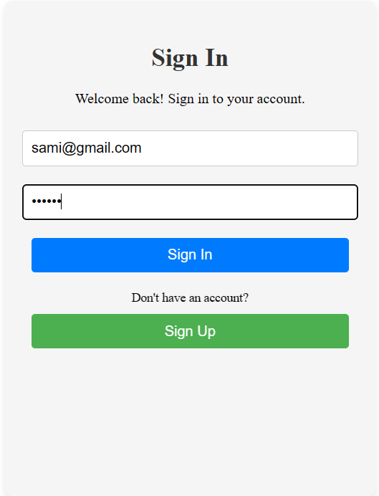

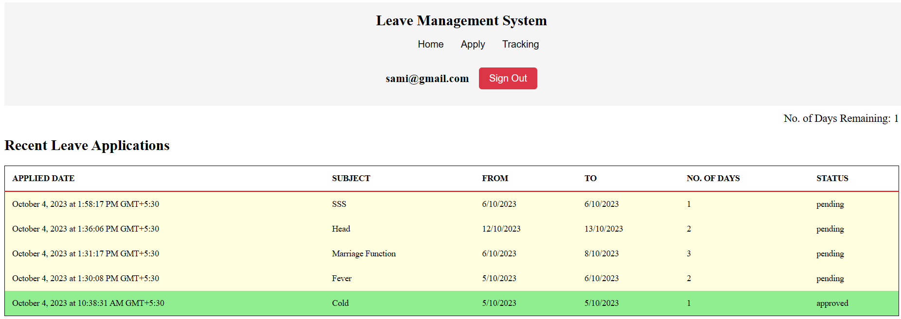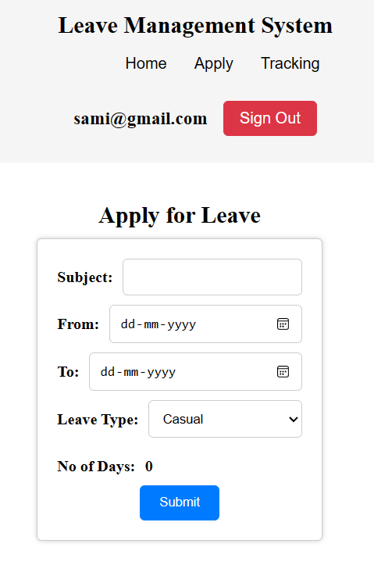

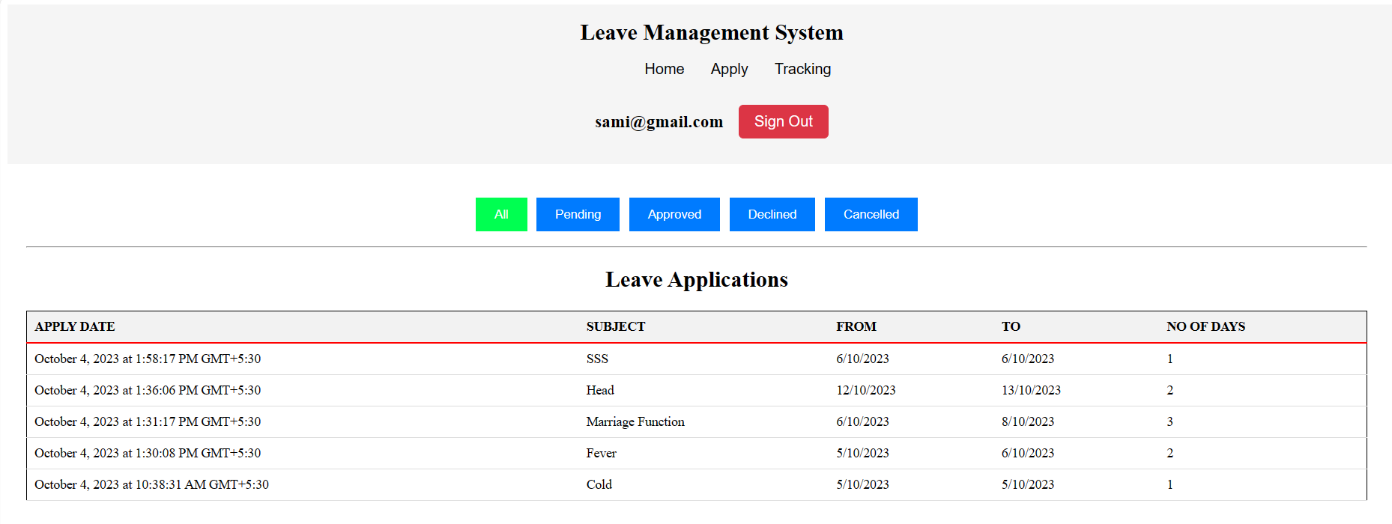

**Result:**

Thus the creation of web application to develop a leave management system for an organization where users can apply different types of leaves such as casual leave and medical leave. They also can view the available number of days has been done successfully and the output is verified.

|  |  |
| --- | --- |
| **Ex No:07** | **Develop a simple dashboard for project management where the statuses of various tasks are available. New tasks can be added and the status of existing tasks can be changed**  **among Pending, InProgress or Completed.** |
| **Date:** |

**Aim:**

To Create a web application to develop a leave management system for an organization where users can apply different types of leaves such as casual leave and medical leave. They also can view the available

number of days.

**Algorithm:**

Step 1 : Start the program

Step 2 : Create a login page to enter into website

Step 3 : Create page for see the allocated tasks from team leader

Step 4 : Create a page for display the entire project details

Step 5 : Create a page for visualize the project status

Step 6 : Create a server for the data sharing

Step 7 :Stop the progarm

**Program:**

App.jsx

import { useState } from "react";

import "./App.css";

import { ProjectStatus } from "./Components/ProjectStautus";

import { BrowserRouter, Routes, Route } from "react-router-dom";

import { Nav } from "./Navbar/Nav";

import { Home } from "./Components/Home";

import { ProjectDetail } from "./Components/ProjectDetail";

import { Index } from "./Sign";

function App() {

return (

<>

<BrowserRouter>

<Routes>

<Route path="/" element={<Index />} />

<Route path="/home" element={<Home />} />

<Route path="/prod" element={<ProjectDetail />} />

<Route path="/pros" element={<ProjectStatus />} />

</Routes>

</BrowserRouter>

</>

);

}

export default App;

Home.jsx

import React, { useState, useEffect } from "react";

import "./Home.css";

import { Nav } from "../Navbar/Nav";

import axios from "axios"; // Import Axios

import { useUserContext } from "../Context/UserContext";

export const Home = () => {

const { user } = useUserContext();

const userStorageKey = `userData_${user.name}`; // Create a unique storage key for each user

const storedUserData = JSON.parse(localStorage.getItem(userStorageKey)) || {};

const mergedUser = { ...user, ...storedUserData };

localStorage.setItem(userStorageKey, JSON.stringify(mergedUser));

const [allotedTask, setAllotedTask] = useState([]);

const [projectData, setProjectData] = useState([]);

const [isUpdatingProject, setIsUpdatingProject] = useState(false);

useEffect(() => {

console.log("Fetching task data...");

axios

.get("http://localhost:3001/api/tasks")

.then((response) => {

const tasks = response.data;

console.log("Received task data:", tasks);

setAllotedTask(tasks[mergedUser.name] || []);

})

.catch((error) => {

console.error("Error fetching task data:", error);

});

axios

.get("http://localhost:3001/api/project")

.then((response) => {

const projectData = response.data;

console.log("Received project data:", projectData);

setProjectData(projectData);

})

.catch((error) => {

console.error("Error fetching project data:", error);

});

}, [mergedUser.name]);

const handleButtonClick = (index) => {

const updatedTasks = [...allotedTask];

if (updatedTasks[index].status === "Not Started") {

updatedTasks[index].status = "Pending";

} else if (updatedTasks[index].status === "Pending") {

updatedTasks[index].status = "Complete";

}

console.log("Updating task data...", updatedTasks);

axios

.put("http://localhost:3001/api/tasks/update", {

user: mergedUser.name,

task: updatedTasks[index],

})

.then((response) => {

console.log("Updated task data:", response.data);

setAllotedTask(updatedTasks);

const allTasksCompleted = updatedTasks.every(

(task) => task.status === "Complete"

);

if (allTasksCompleted) {

updateProjectStatus("Completed");

} else {

updateProjectStatus("Pending");

}

})

.catch((error) => {

console.error("Error updating task data:", error);

});

};

const updateProjectStatus = async (status) => {

setIsUpdatingProject(true);

await axios

.put("http://localhost:3001/api/project", {

user: mergedUser.name,

status: status,

})

.then((response) => {

console.log("Updated project status:", response.data);

setIsUpdatingProject(false);

})

.catch((error) => {

console.error("Error updating project status:", error);

setIsUpdatingProject(false);

});

};

if (!mergedUser || !mergedUser.name) {

return (

<div>

<Nav />

<div className="home-container">

<p>Loading user data...</p>

</div>

</div>

);

}

const teamLeader = "Ramesh";

return (

<div>

<Nav />

<div className="home-container">

<h3>Your Allotted Tasks</h3>

<table className="task-table">

<thead>

<tr>

<th style={{ color: "black" }}>S.No</th>

<th style={{ color: "black" }}>Work</th>

<th style={{ color: "black" }}>Duration</th>

<th style={{ color: "black" }}>Action</th>

</tr>

</thead>

<tbody>

{allotedTask.map((task, index) => (

<tr key={index}>

<td>{index + 1}</td>

<td>{task.Work}</td>

<td>{task.duration}</td>

<td>

<button

className={`action-button ${

task.status === "Complete" ? "disabled" : ""

}`}

onClick={() => handleButtonClick(index)}

disabled={task.status === "Complete"}

>

{task.status === "Not Started"

? "Start"

: task.status === "Pending"

? "Complete"

: "Completed"}

</button>

</td>

</tr>

))}

</tbody>

</table>

</div>

</div>

);

};

ProjectDetails.jsx

// ProjectDetail.jsx

import React, { useState, useEffect } from "react";

import "./ProjectDetail.css";

import { Nav } from "../Navbar/Nav";

import axios from "axios"; // Import Axios

import { useUserContext } from "../Context/UserContext";

export const ProjectDetail = () => {

const { user } = useUserContext();

const teamLeader = "Ramesh";

const [project, setProject] = useState([]);

useEffect(() => {

axios

.get("http://localhost:3001/api/project") // Replace with your server's endpoint

.then((response) => {

setProject(response.data);

})

.catch((error) => {

console.error("Error fetching project data:", error);

});

}, []);

// Function to get the row color based on status

const getRowColor = (status) => {

switch (status) {

case "Completed":

return "green";

case "Pending":

return "yellow";

case "Not Start":

return "red";

default:

return "";

}

};

// Calculate total duration

const totalDuration = project.reduce((acc, item) => acc + item.duration, 0);

// Calculate end date (assuming a start date is known)

const startDate = new Date(); // Replace with the actual start date

const endDate = new Date(startDate);

endDate.setDate(startDate.getDate() + totalDuration);

return (

<div>

<Nav />

<div className="project-detail-container">

<h4 className="team-leader">Team Leader: {teamLeader}</h4>

<table className="project-table">

<thead>

<tr>

<th>Name</th>

<th>Task</th>

<th>Duration</th>

<th>Status</th>

</tr>

</thead>

<tbody>

{project.map((item, index) => (

<tr

key={index}

className={`project-row ${getRowColor(item.Status)}`}

>

<td>{item.name}</td>

<td>{item.Task}</td>

<td>{item.duration}</td>

<td>{item.Status}</td>

</tr>

))}

</tbody>

</table>

<p className="total-duration">Total Duration: {totalDuration} min</p>

{/* <p className="end-date">End Date: {endDate.toDateString()}</p> */}

</div>

</div>

);

};

Chart.jsx

import React from "react";

import { PieChart, Pie, Cell, Tooltip, Legend } from "recharts";

import "./Chart.css";

const ChartPage = ({ employeeData }) => {

const COLORS = {

Completed: "#00C49F",

Pending: "#FFBB28",

"Not Start": "grey",

};

const sortedData = employeeData.sort((a, b) => {

const statusOrder = {

Completed: 0,

Pending: 1,

"Not Start": 2,

};

return statusOrder[a.Status] - statusOrder[b.Status];

});

const totalCompletedPercentage = (

(sortedData.reduce((acc, project) => {

if (project.Status === "Completed") {

return acc + project.duration;

}

return acc;

}, 0) /

sortedData.reduce((acc, project) => acc + project.duration, 0)) *

100

).toFixed(2);

const renderCustomizedLabel = ({

cx,

cy,

midAngle,

innerRadius,

outerRadius,

index,

}) => {

const RADIAN = Math.PI / 180;

const radius = innerRadius + (outerRadius - innerRadius) * 0.5;

const x = cx + (radius + 10) * Math.cos(-midAngle * RADIAN); // Adjust 10 for label distance

const y = cy + (radius + 10) * Math.sin(-midAngle * RADIAN); // Adjust 10 for label distance

return (

<text

x={x}

y={y}

fill="black"

textAnchor={x > cx ? "start" : "end"}

dominantBaseline="central"

>

{`${sortedData[index].name}-${sortedData[index].Status}`}

</text>

);

};

const chartData = sortedData.map((project) => ({

name: project.name,

value: project.duration,

}));

return (

<div className="chart-page-container">

<h1>Chart Page</h1>

<div>

<PieChart width={800} height={400}>

<Pie

data={chartData}

cx={400}

cy={200}

labelLine={false}

label={renderCustomizedLabel}

outerRadius={160}

fill="#8884d8"

dataKey="value"

>

{chartData.map((entry, index) => (

<Cell

key={`cell-${index}`}

fill={COLORS[sortedData[index].Status]}

/>

))}

</Pie>

<Tooltip />

<Legend />

</PieChart>

<div style={{ textAlign: "center" }}>

Total Completed Percentage: {totalCompletedPercentage}%

</div>

</div>

</div>

);

};

export default ChartPage;

Server.js

const express = require("express");

const app = express();

const fs = require("fs");

const cors = require("cors");

const PORT = process.env.PORT || 3001;

const JSON_TASKS_FILE_PATH = "./task.json"; // Replace with the actual path to your task JSON file

const JSON_PROJECT_FILE_PATH = "./project.json"; // Replace with the actual path to your project JSON file

app.use(express.json());

app.use(cors());

app.put("/api/project", async (req, res) => {

const userName = req.body.user;

const updatedStatus = req.body.status;

console.log("Requested update");

await fs.readFile(JSON_PROJECT_FILE_PATH, "utf8", (readErr, data) => {

if (readErr) {

console.error(readErr);

res.status(500).json({ error: "Internal Server Error" });

return;

}

try {

const projectData = JSON.parse(data);

console.log("read");

// Find the project with the matching user name

const projectToUpdate = projectData.find(

(project) => project.name === userName

);

if (projectToUpdate) {

projectToUpdate.Status = updatedStatus; // Update the status

// Write the modified data back to the JSON file

fs.writeFile(

JSON_PROJECT_FILE_PATH,

JSON.stringify(projectData),

(writeErr) => {

if (writeErr) {

console.error(writeErr);

res.status(500).json({ error: "Error updating project status" });

return;

}

console.log("error");

res.json({ success: true });

}

);

} else {

res.status(404).json({ error: "User not found in project data" });

}

} catch (parseError) {

console.error(parseError);

res.status(500).json({ error: "Failed to parse JSON" });

}

});

});

app.get("/api/tasks", (req, res) => {

console.log("Requested");

fs.readFile(JSON_TASKS_FILE_PATH, "utf8", (err, data) => {

if (err) {

console.error(err);

res.status(500).json({ error: "Internal Server Error" });

return;

}

try {

const tasks = JSON.parse(data);

res.json(tasks);

} catch (parseError) {

console.error(parseError);

res.status(500).json({ error: "Failed to parse JSON" });

}

});

});

app.put("/api/tasks/update", (req, res) => {

const userName = req.body.user;

const updatedTask = req.body.task;

console.log("Requested");

fs.readFile(JSON_TASKS_FILE_PATH, "utf8", (readErr, data) => {

if (readErr) {

console.error(readErr);

res.status(500).json({ error: "Internal Server Error" });

return;

}

try {

const tasksData = JSON.parse(data);

if (tasksData[userName]) {

const userTasks = tasksData[userName];

// Find and update the specific task by matching its properties

const taskToUpdate = userTasks.find(

(task) =>

task.Work === updatedTask.Work &&

task.duration === updatedTask.duration

);

if (taskToUpdate) {

taskToUpdate.status = updatedTask.status;

}

// Write the modified data back to the JSON file

fs.writeFile(

JSON_TASKS_FILE_PATH,

JSON.stringify(tasksData),

(writeErr) => {

if (writeErr) {

console.error(writeErr);

res.status(500).json({ error: "Error updating tasks" });

return;

}

res.json({ success: true });

}

);

} else {

res.status(404).json({ error: "User not found" });

}

} catch (parseError) {

console.error(parseError);

res.status(500).json({ error: "Failed to parse JSON" });

}

});

});

app.get("/api/project", (req, res) => {

console.log("Requested");

fs.readFile(JSON_PROJECT_FILE_PATH, "utf8", (err, data) => {

if (err) {

console.error(err);

res.status(500).json({ error: "Internal Server Error" });

return;

}

try {

const project = JSON.parse(data);

res.json(project);

} catch (parseError) {

console.error(parseError);

res.status(500).json({ error: "Failed to parse JSON" });

}

});

});

app.listen(PORT, () => {

console.log(`Server is running on port ${PORT}`);

});

**Output:-**

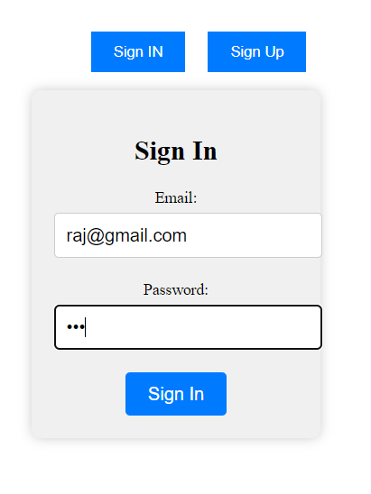

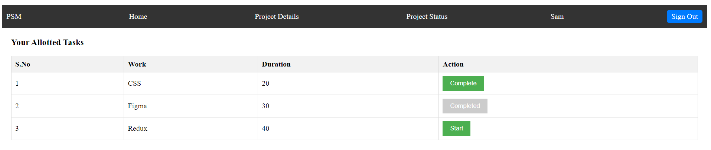

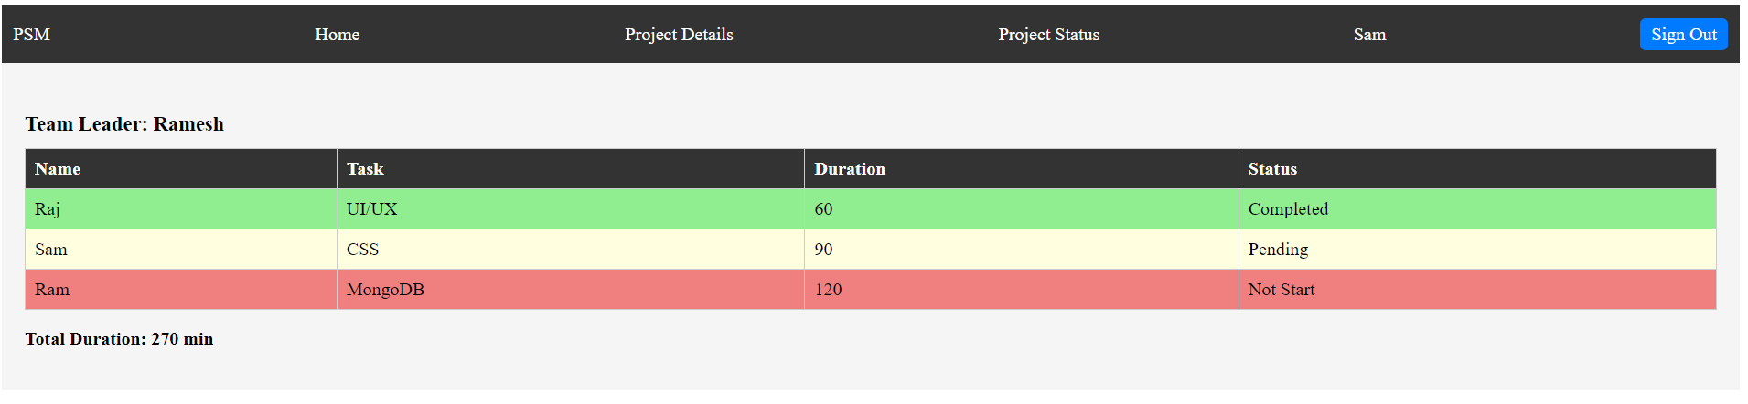

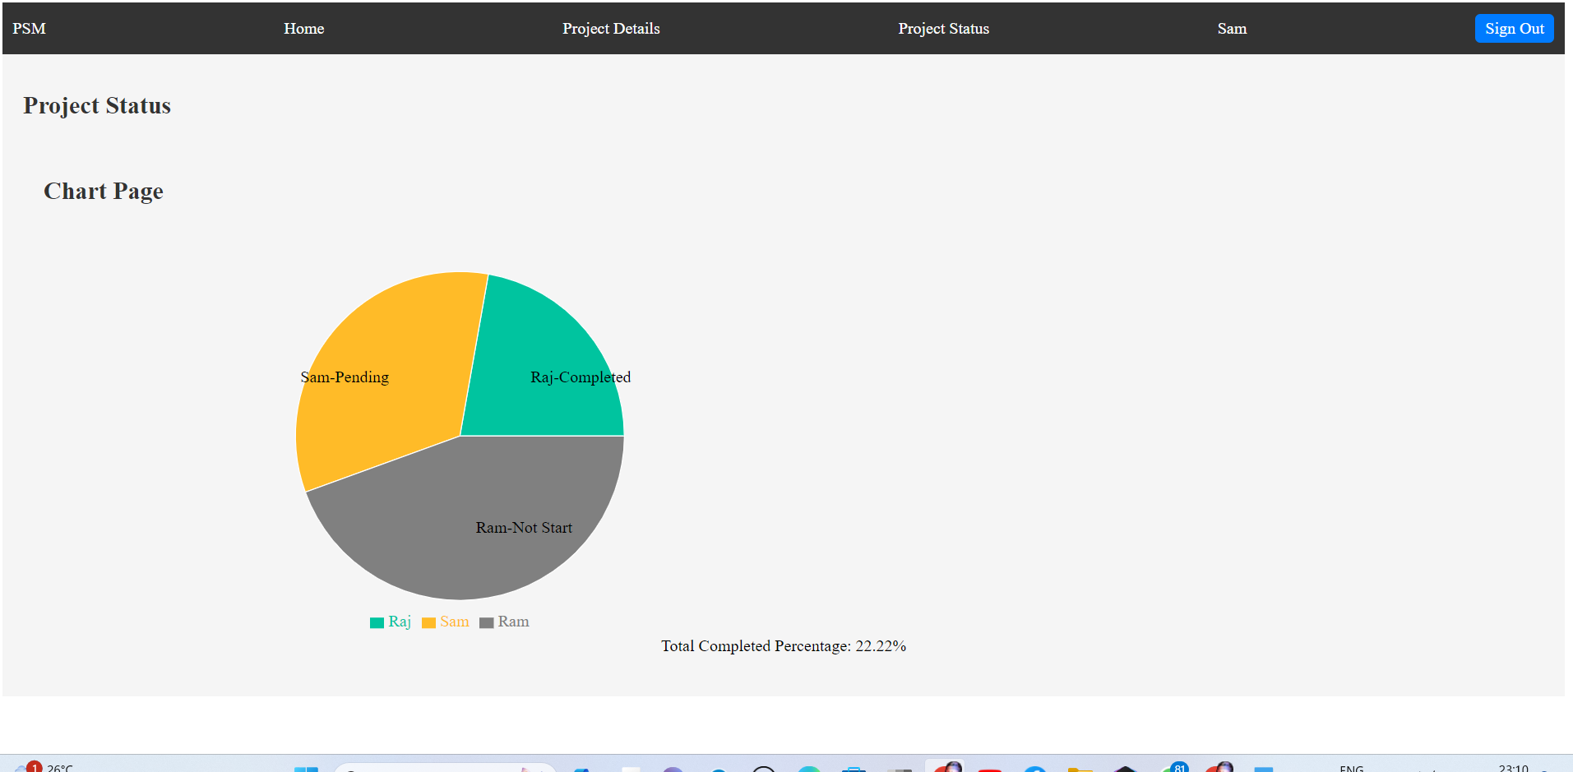

**Result:**

Thus the creation of web application to develop a simple dashboard for project management where the statuses of various tasks are available. New tasks can be added and the status of existing tasks can be changed among Pending, InProgress or Completed has been done successfully and the output is verified.

|  |  |
| --- | --- |
| **Ex No:08** | **Develop an online survey application where a collection of questions is available and users are asked to answer any random 5 questions.** |
| **Date:** |

**Aim:**

To Create a web application to develop an online survey application where a collection of questions is available and users are asked to answer any random 5 questions.

**Algorithm:**

Step 1 : Start the program

Step 2 : Create a login page to enter into website

Step 3 : Create page for enter the email address

Step 4 : Create a page for display the random five questions

Step 5 : Create a page for display the final score

Step 6 : Create a page for Visualize the final survey report

Step 7 :Stop the progarm

**Program:**

App.jsx

import React, { useState } from 'react';

import { BrowserRouter as Router, Route, Routes } from 'react-router-dom';

import Welcome from './pages/Welcome';

import Quiz from './pages/Quiz';

import Result from './pages/Result';

import { QuizContext } from './pages/QuizContext';

function App() {

const [userEmail, setUserEmail] = useState('');

const [score, setScore] = useState(0);

return (

<Router>

<QuizContext.Provider value={{ userEmail, setUserEmail, score, setScore,questions }}>

<div className="App">

<h1>Quiz App</h1>

<Routes>

<Route exact path="/" element={<Welcome/>} />

<Route path="/quiz" element={<Quiz/>} />

<Route path="/result" element={<Result/>} />

</Routes>

</div>

</QuizContext.Provider>

</Router>

);

}

export default App;

Welcome.jsx

// Welcome.jsx

import React, { useContext } from 'react';

import { Link } from 'react-router-dom';

import { QuizContext } from './QuizContext';

import './Welcome.css'; // Import the CSS file

function Welcome() {

const { userEmail, setUserEmail } = useContext(QuizContext);

const handleInputChange = (e) => {

setUserEmail(e.target.value);

};

return (

<div className="welcome-container">

<div className="welcome-content">

<h1>Welcome to the Online Survey</h1>

<p>Please enter your email:</p>

<input type="email" value={userEmail} onChange={handleInputChange} />

<Link to="/quiz">

<button className="start-quiz-button">Start Quiz</button>

</Link>

</div>

</div>

);

}

export default Welcome;

Quiz.jsx

// Quiz.jsx

import React, { useContext, useState, useEffect } from 'react';

import { Link } from 'react-router-dom';

import { QuizContext } from './QuizContext';

import './Quiz.css'; // Import the CSS file

function Quiz() {

const { userEmail, setScore, questions } = useContext(QuizContext);

const [currentQuestionIndex, setCurrentQuestionIndex] = useState(0);

const [selectedAnswer, setSelectedAnswer] = useState('');

const [correctAnswer, setCorrectAnswer] = useState('');

const [isAnswered, setIsAnswered] = useState(false);

const [quizQuestions, setQuestions] = useState([]);

useEffect(() => {

// Shuffle the questions array and select 5 random questions

const shuffledQuestions = shuffleArray(questions).slice(0, 5);

setQuestions(shuffledQuestions);

}, []);

// Check if quizQuestions is populated

if (quizQuestions.length === 0) {

return <div>Loading...</div>; // Render loading indicator

}

const currentQuestion = quizQuestions[currentQuestionIndex];

const handleAnswerSelect = (option) => {

setSelectedAnswer(option);

setIsAnswered(true);

setCorrectAnswer(currentQuestion.answer);

};

const handleNextQuestion = () => {

if (isAnswered) {

if (selectedAnswer === currentQuestion.answer) {

setScore((prevScore) => prevScore + 1);

}

setSelectedAnswer('');

setCorrectAnswer('');

setIsAnswered(false);

if (currentQuestionIndex < quizQuestions.length - 1) {

setCurrentQuestionIndex((prevIndex) => prevIndex + 1);

} else {

// Handle quiz completion here

}

} else {

alert('Please select an answer before moving to the next question.');

}

};

// Calculate the progress percentage

const progressPercentage = ((currentQuestionIndex + 1) / quizQuestions.length) * 100;

return (

<div className="quiz-container">

<div className="quiz-content">

<h2>Question {currentQuestionIndex + 1}</h2>

<p>{currentQuestion.question}</p>

<ul>

{currentQuestion.options.map((option, index) => (

<li

key={index}

onClick={() => handleAnswerSelect(option)}

className={`${

selectedAnswer === option

? option === correctAnswer

? 'correct-answer'

: 'wrong-answer'

: ''

}`}

>

{option}

</li>

))}

</ul>

<p>Progress: {progressPercentage.toFixed(2)}%</p>

{currentQuestionIndex < quizQuestions.length - 1 ? (

<button onClick={handleNextQuestion}>Next</button>

) : (

<Link to="/result">Finish Quiz</Link>

)}

</div>

</div>

);

}

// Function to shuffle an array

function shuffleArray(array) {

let shuffledArray = array.slice();

for (let i = shuffledArray.length - 1; i > 0; i--) {

const j = Math.floor(Math.random() * (i + 1));

[shuffledArray[i], shuffledArray[j]] = [shuffledArray[j], shuffledArray[i]];

}

return shuffledArray;

}

export default Quiz;

Result.jsx

// Result.jsx

import React, { useContext, useEffect, useState } from 'react';

import { Link } from 'react-router-dom';

import { QuizContext } from './QuizContext';

import axios from 'axios'; // Import Axios for making HTTP requests

import './Result.css'; // Import the CSS file

function Result() {

const { userEmail, score, setScore, questions } = useContext(QuizContext);

const [timestamp, setTimestamp] = useState('');

useEffect(() => {

// Get the current timestamp when the component mounts

const now = new Date();

setTimestamp(now.toISOString());

}, []);

const handleRestartQuiz = () => {

// Send a POST request to your MongoDB Atlas database

axios.post('http://localhost:5000/api/saveResult', { email: userEmail, score, timestamp })

.then((response) => {

// Handle the response if needed

console.log('Data sent successfully:', response.data);

})

.catch((error) => {

// Handle any errors

console.error('Error sending data:', error);

});

// Reset the score

setScore(0);

};

return (

<div className="result-container">

<div className="result-content">

<h2>Quiz Completed, {userEmail}!</h2>

<p>Your Score: {score} out of {questions.length}</p>

<Link to="/">

<button onClick={handleRestartQuiz}>Restart Quiz</button>

</Link>

</div>

</div>

);

}

export default Result;

Survey.jsx

// jsx

import React, { useState, useEffect } from 'react';

import axios from 'axios';

import { BarChart, Bar, XAxis, YAxis, CartesianGrid, Tooltip, Legend } from 'recharts';

import './Result.css';

function Survey () {

const [results, setResults] = useState([]);

useEffect(() => {

axios.get('http://localhost:5001/api/results')

.then((response) => {

setResults(response.data);

})

.catch((error) => {

console.error(error);

});

}, []);

const data = results.reduce((acc, result) => {

const score = result.score;

if (!acc[score]) {

acc[score] = { name: `Score ${score}`, value: 0 };

}

acc[score].value++;

return acc;

}, {});

const dataArray = Object.values(data);

return (

<div className="result-container">

<h2 className="result-heading">Quiz Results</h2>

<BarChart width={730} height={250} data={dataArray}>

<CartesianGrid strokeDasharray="3 3" />

<XAxis dataKey="name" />

<YAxis />

<Tooltip />

<Legend />

<Bar dataKey="value" fill="#8884d8" />

</BarChart>

<table className="result-table">

<thead>

<tr>

<th>S.NO</th>

<th>Date</th>

<th>Email</th>

<th>Score</th>

</tr>

</thead>

<tbody>

{results.map((result, index) => (

<tr key={result._id}>

<td>{index + 1}</td>

<td>{new Date(result.timestamp).toLocaleString()}</td>

<td>{result.email}</td>

<td>{result.score}</td>

</tr>

))}

</tbody>

</table>

</div>

);

}

export default Survey;

**Output:-**

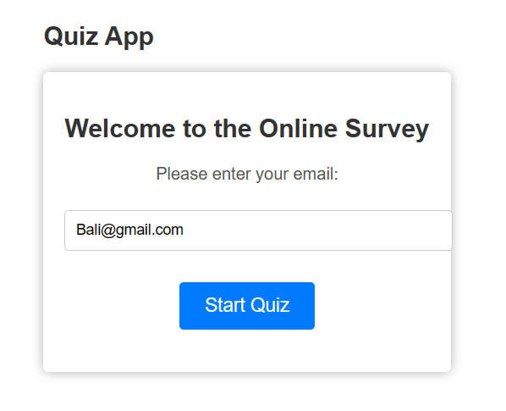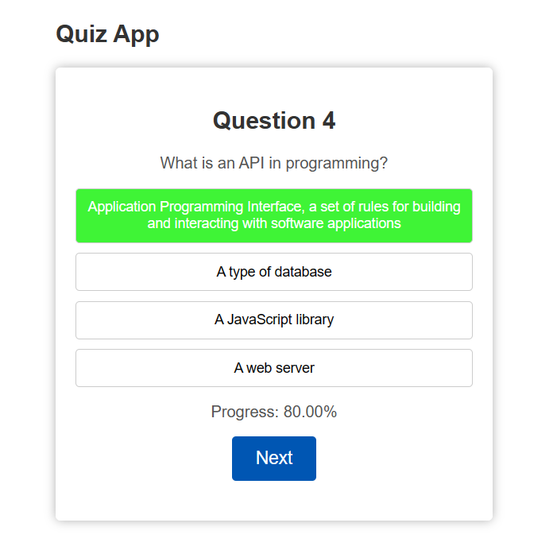

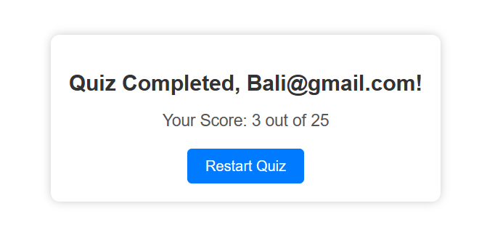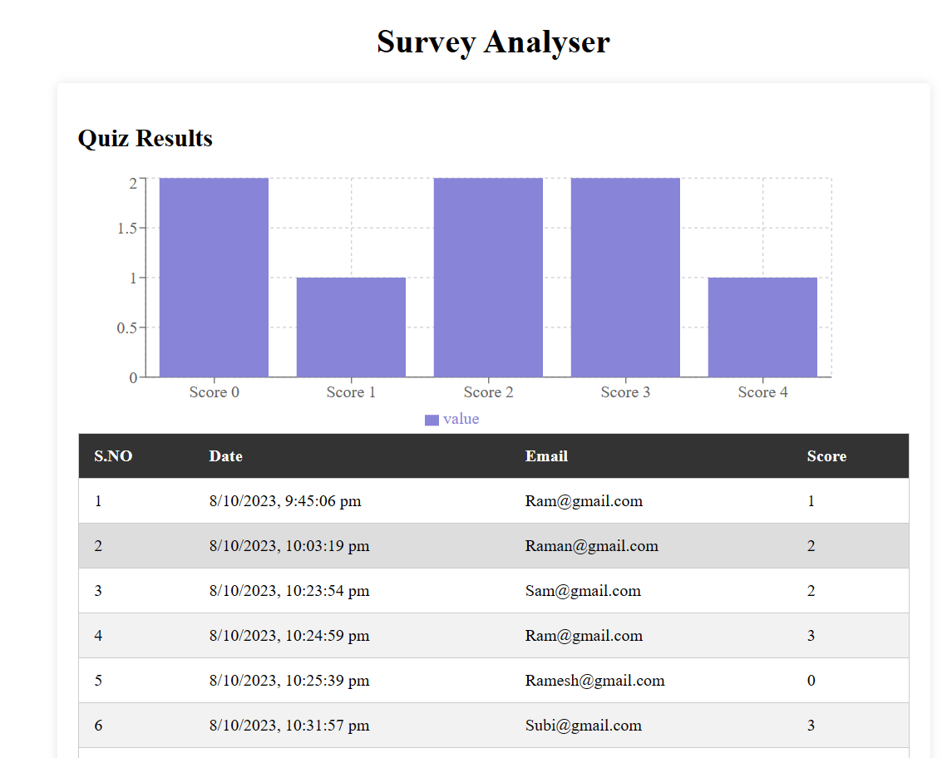

**Result:**

Thus the creation of web application to develop an online survey application where a collection of questions is available and users are asked to answer any random 5 questions has been done successfully and the output is verified.